# Prerequisites

<< Text from AKAMAI TEAM HERE>>

Contents

Prerequisites 1

**Introduction** 2

**Setting up IDP** 4

**Header Based Authentication** 14

**Remote Desktop** 22

**Deployment** 30

**SSH** 30

**Kerberos Authentication** 39

# **Introduction**

Azure Active Directory and Akamai Enterprise Application Access integration allows seamless access to legacy applications hosted in the cloud or on-premises. The integrated solution takes advantages of all the modern capabilities of Azure Active Directory like [Azure AD conditional access](https://docs.microsoft.com/en-us/azure/active-directory/active-directory-conditional-access-azure-portal), [Azure AD Identity Protection](https://docs.microsoft.com/en-us/azure/active-directory/active-directory-identityprotection) and [Azure AD Identity Governance](https://docs.microsoft.com/en-us/azure/active-directory/governance/identity-governance-overview) for legacy applications access without app modifications or agents installation.

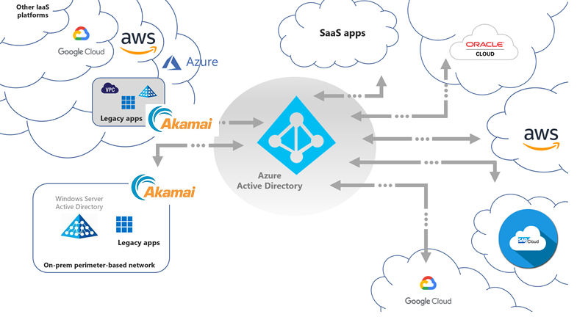

Figure 1 – Where Akamai EAA fits into the broader Hybrid Secure Access scenario

**Key Authentication Scenarios**

Apart from Azure Active Directory native integration support for modern authentication protocols like Open ID Connect, SAML and WS-Fed, Akamai EAA extends secure access for legacy-based authentication apps for both internal and external access with Azure AD, enabling modern scenarios (e.g. password-less access) to these applications. This include:

* Header-based authentication apps
* Remote Desktop
* SSH (Secure Shell)
* Kerberos authentication apps
* VNC (Virtual Network Computing)
* Anonymous auth or no inbuilt authentication apps
* NTLM authentication apps (protection with dual prompts for the user)
* Forms Based Application (protection with dual prompts for the user)

**Integration Scenarios**

Microsoft and Akamai EAA partnership allows the flexibility to meet your business requirements by supporting multiple integration scenarios based on your business requirement. These could be used to provide zero-day coverage across all applications and gradually classify and configure appropriate policy classifications.

|  |  |
| --- | --- |
| **Integration Scenario 1** |  |
| Akamai EAA is configured as a single application on the Azure AD.  Admin can configure the CA Policy on the Application and once the conditions are satisfied users can gain access to the Akamai EAA Portal.  Pros:   * You need to only configure IDP once   Cons:   * Users end up having two application portals * Single Common CA Policy coverage for all Applications. |  |
| **Integration Scenario 2** |  |
| Akamai EAA Application are set up individually on the Azure AD Portal. Admin can configure Individual he CA Policy on the Application(s) and once the conditions are satisfied users can directly be redirected to the specific application.  Pros:   * You can define individual CA Policies * All Apps are represented on the 0365 Waffle and myApps.microsoft.com Panel   Cons:   * You need to configure multiple IDPs |  |

# **Setting up IDP**

AKAMAI EAA IDP Configuration.

1. Login to **Akamai Enterprise Application Access Console**
2. **On the Akamai EAA console, Select Identity > Identity Providers**
3. **Click Add Identity Provider**

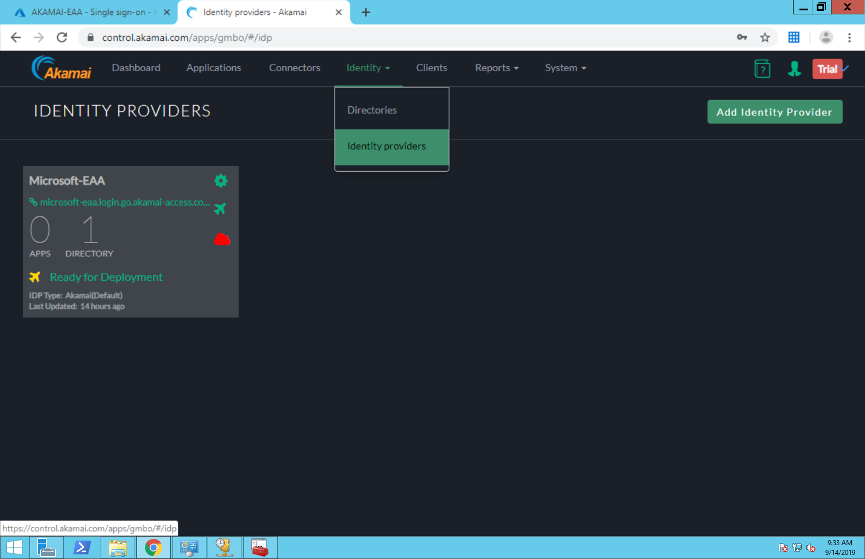

1. **Click Add Identity Provider**
   1. **Specify the Unique Name**
   2. **Choose Third Party SAML** and Click Create Identity Provider and Configure**

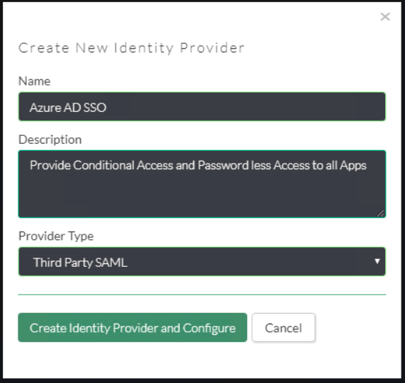

**General Settings**

1. **Identity Intercept** -Specify the name of the (SP base URL–will be used for Azure AD Configuration)

Note: You can choose to have your own custom domain (will require a DNS entry and a Certificate). In this example we are going to use the Akamai Domain

1. **Akamai Cloud Zone -** Select the Appropriate cloud zone.
2. **Certificate Validation** - Check Akamai Documentation (optional)

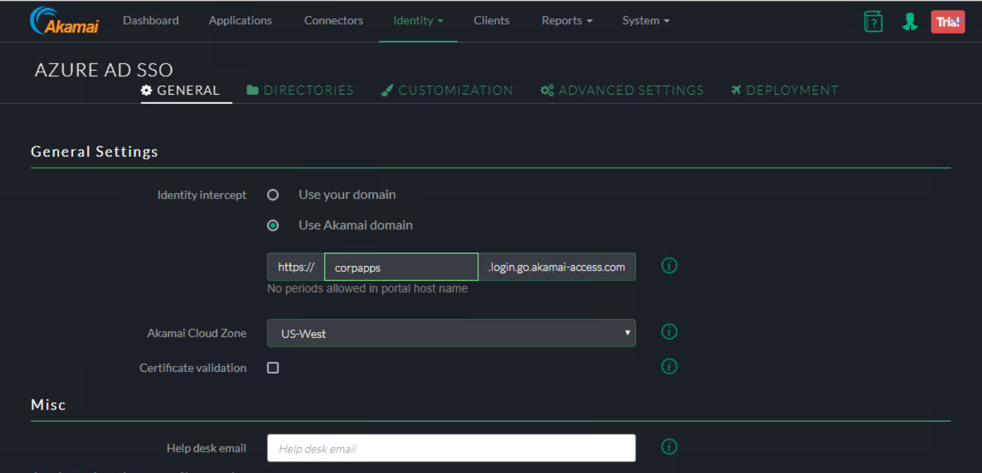

**Authentication Configuration**

1. URL – Specify the URL same as your identity intercept ( this is where users are redirect after authentication)
2. Logout URL : =============================== update ============
3. Sign SAML Request: default unchecked.
4. For the IDP Metadata File, add the Application in the Azure AD Console

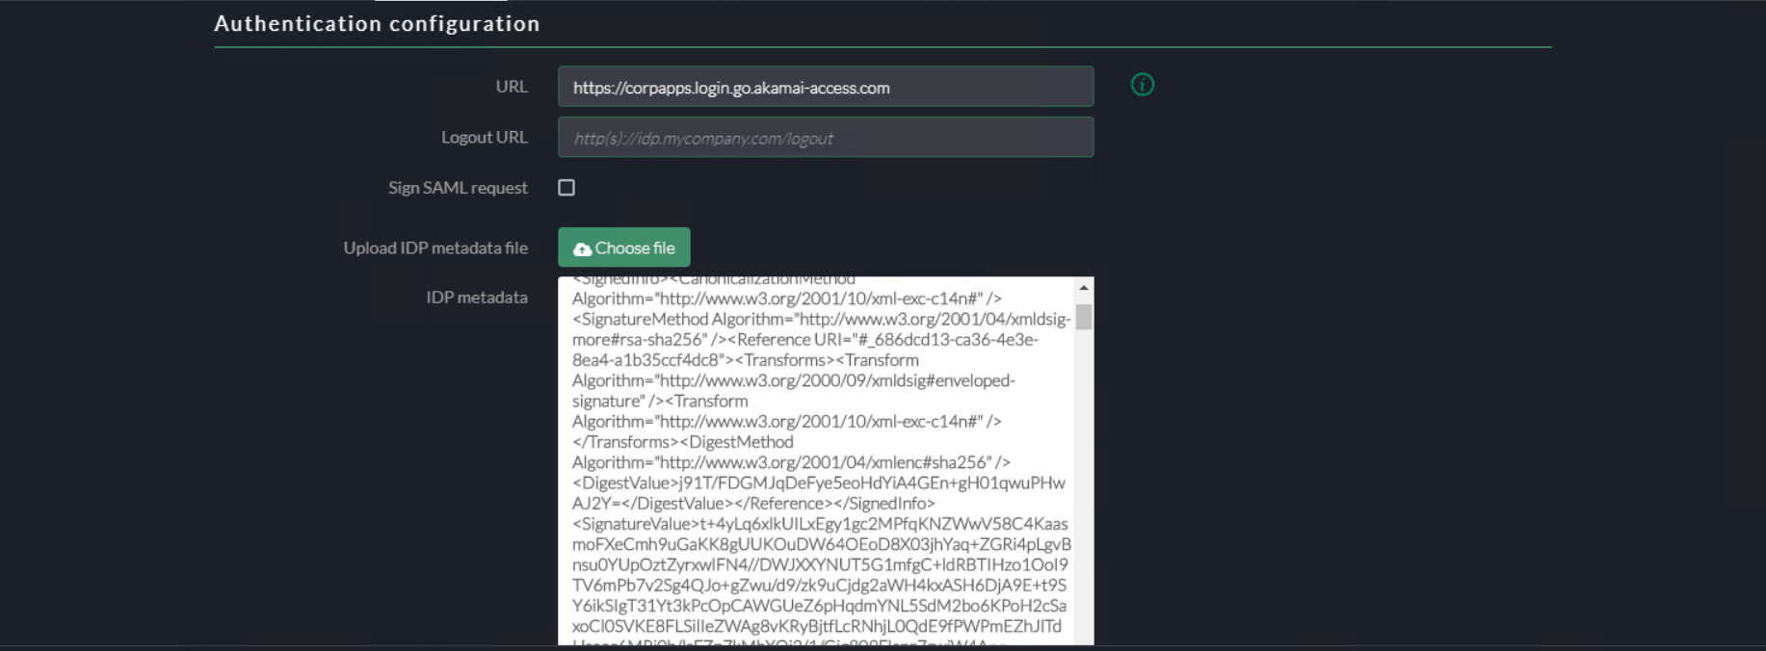

1. Sign in to the [Azure portal](https://portal.azure.com/) using either a work or school account, or a personal Microsoft account.
2. On the left navigation pane, select the **Azure Active Directory** service.
3. Navigate to **Enterprise Applications** and then select **All Applications**.
4. To add new application, select **New application**.
5. In the **Add from the gallery** section, type **Akamai EAA**  in the search box.
6. Select **Akamai EAA** from results panel and then add the app. Wait a few seconds while the app is added to your tenant.

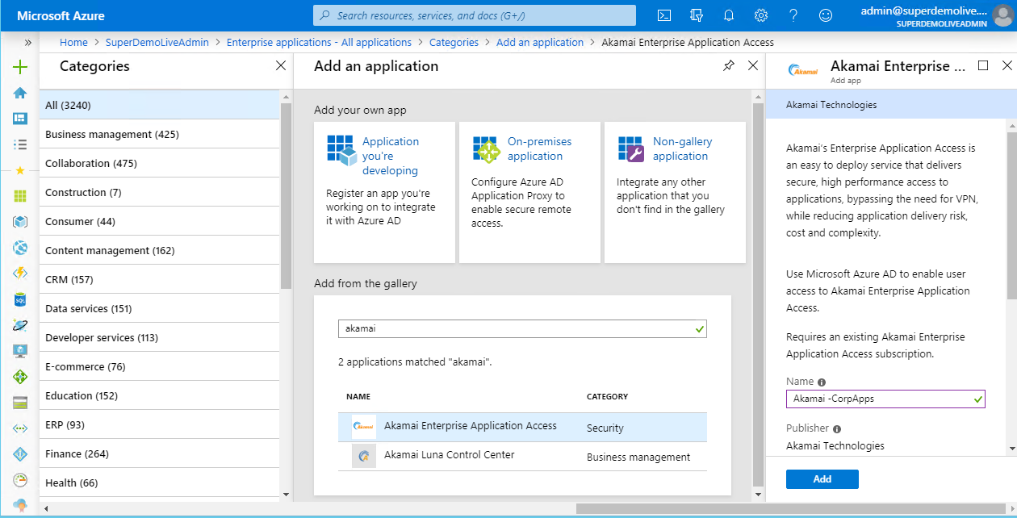

Follow these steps to enable Azure AD SSO in the Azure portal.

1. In the [Azure portal](https://portal.azure.com/), on the **Akamai EAA** application integration page, find the **Manage** section and select **single sign-on**.
2. On the **Select a single sign-on method** page, select **SAML**.
3. On the **Set up single sign-on with SAML** page, click the edit/pen icon for **Basic SAML Configuration** to edit the settings.

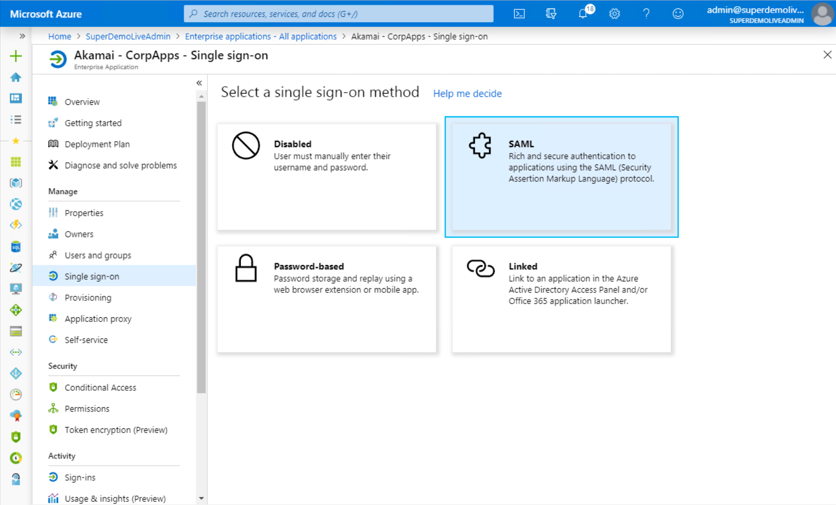

**Configure Azure AD SSO**

On the **Basic SAML Configuration** section, if you wish to configure the application in **IDP** initiated mode, enter the values for the following fields:

a. In the **Identifier** text box, type a URL using the following pattern: https://<Yourapp>.login.go.akamai-access.com/sp/response

b. In the **Reply URL** text box, type a URL using the following pattern: https:// <Yourapp>.login.go.akamai-access.com/sp/response

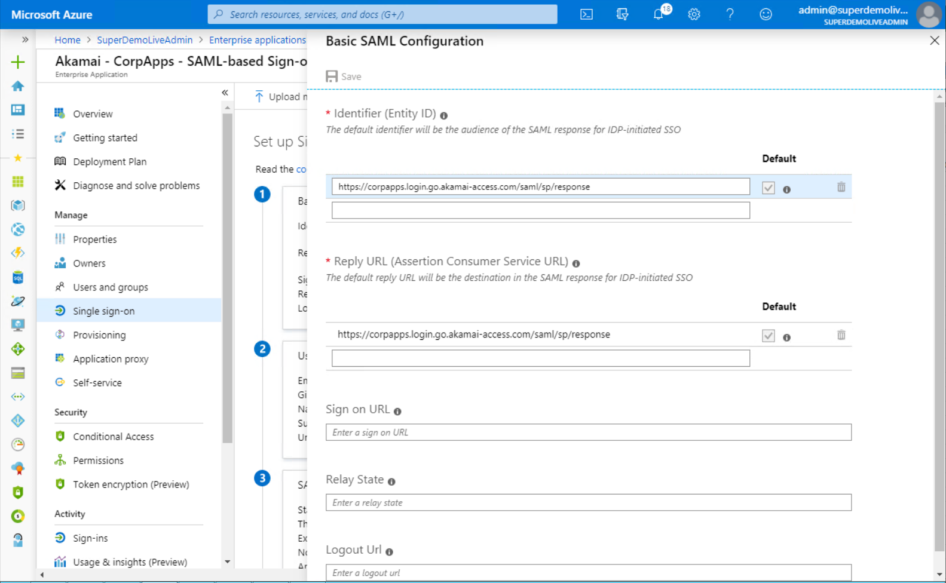

On the **Set up single sign-on with SAML** page, in the **SAML Signing Certificate** section, find **Federation Metadata XML** and select **Download** to download the certificate and save it on your computer. You could also note the **Logout URL** to be updated in Akamai EAA

Also ensure right **Users and Groups** are Assigned to the Application

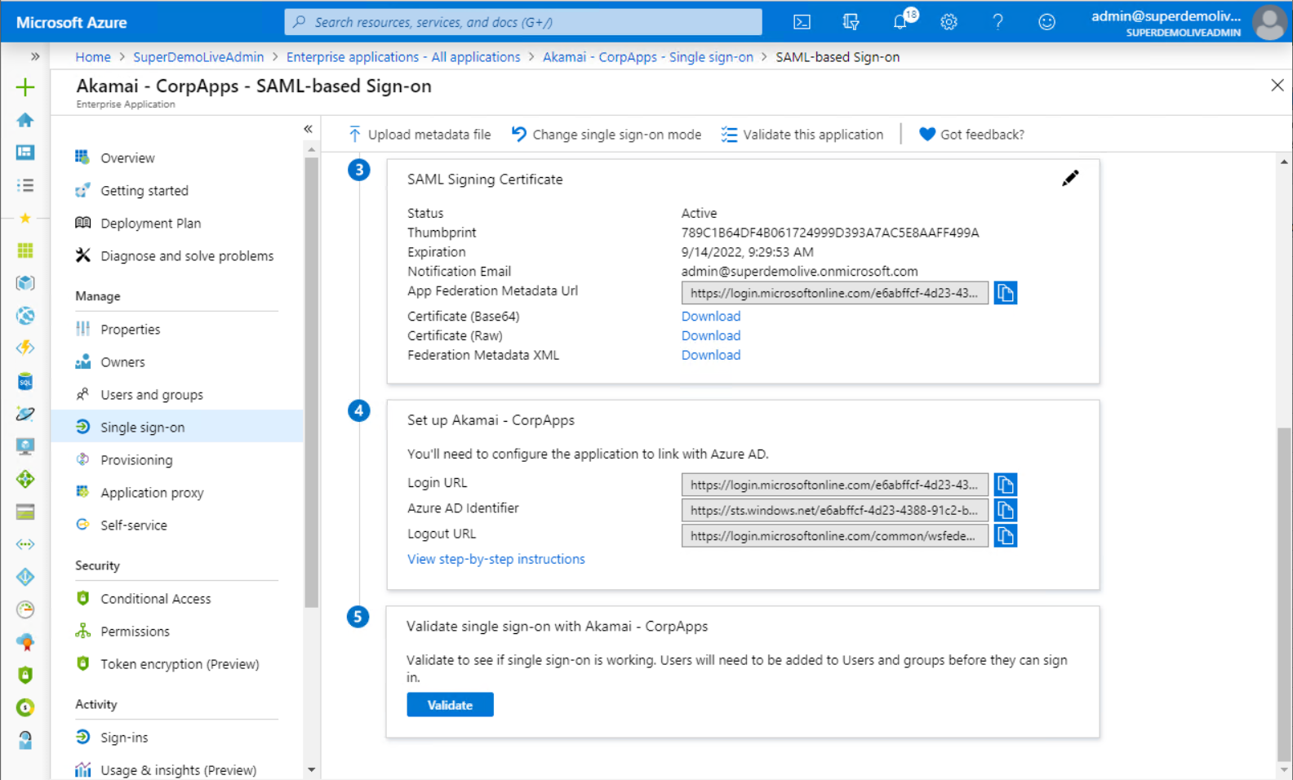

Review the Claims Mapping

* New additional mapping can be added AKAMAI EAA

Note : Akamai EAA does not allow special character in claims Name.

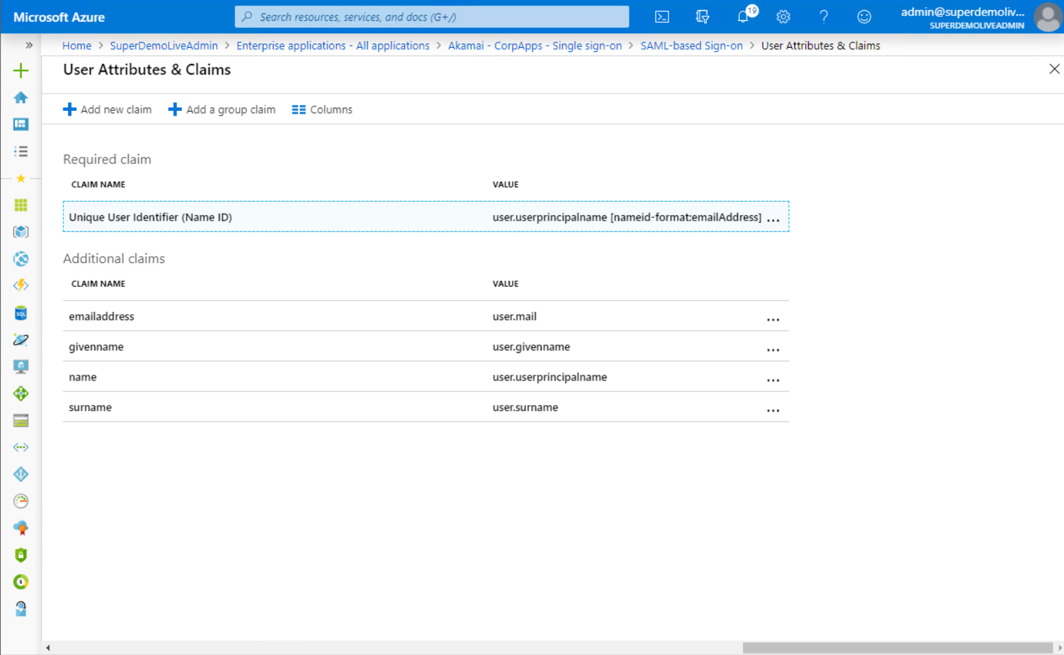

Session Settings

* Leave the settings as default

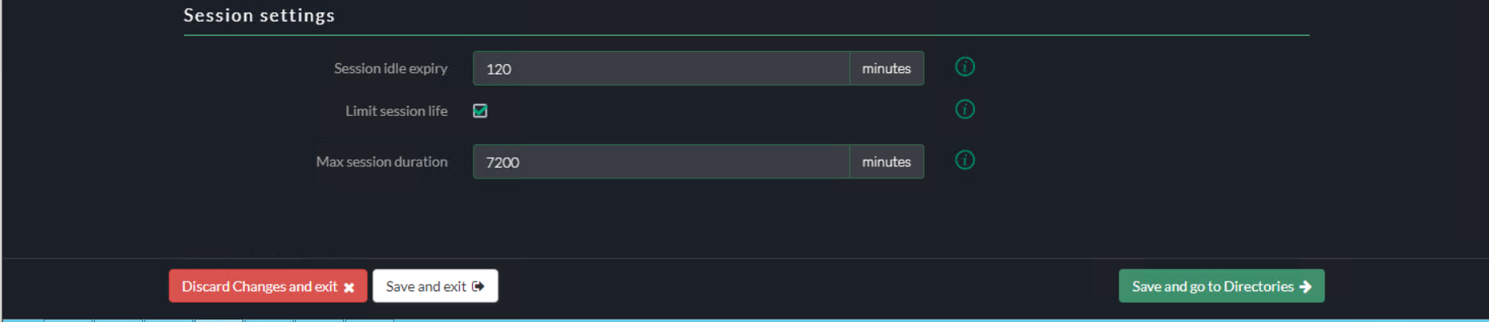

Directories

* Skip the directory configuration

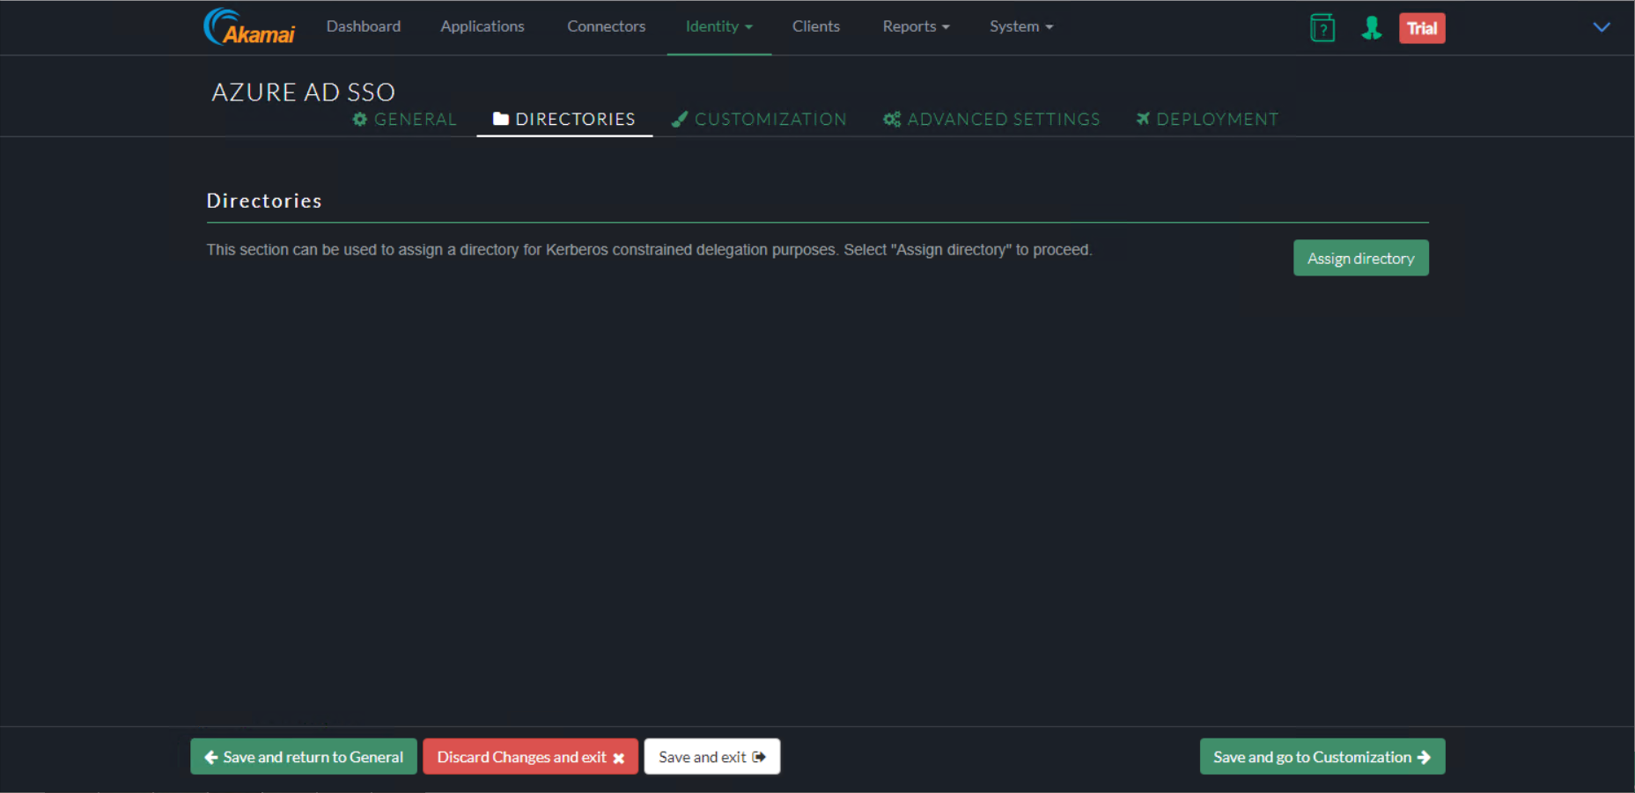

Customization UI

* You could add customization to IDP

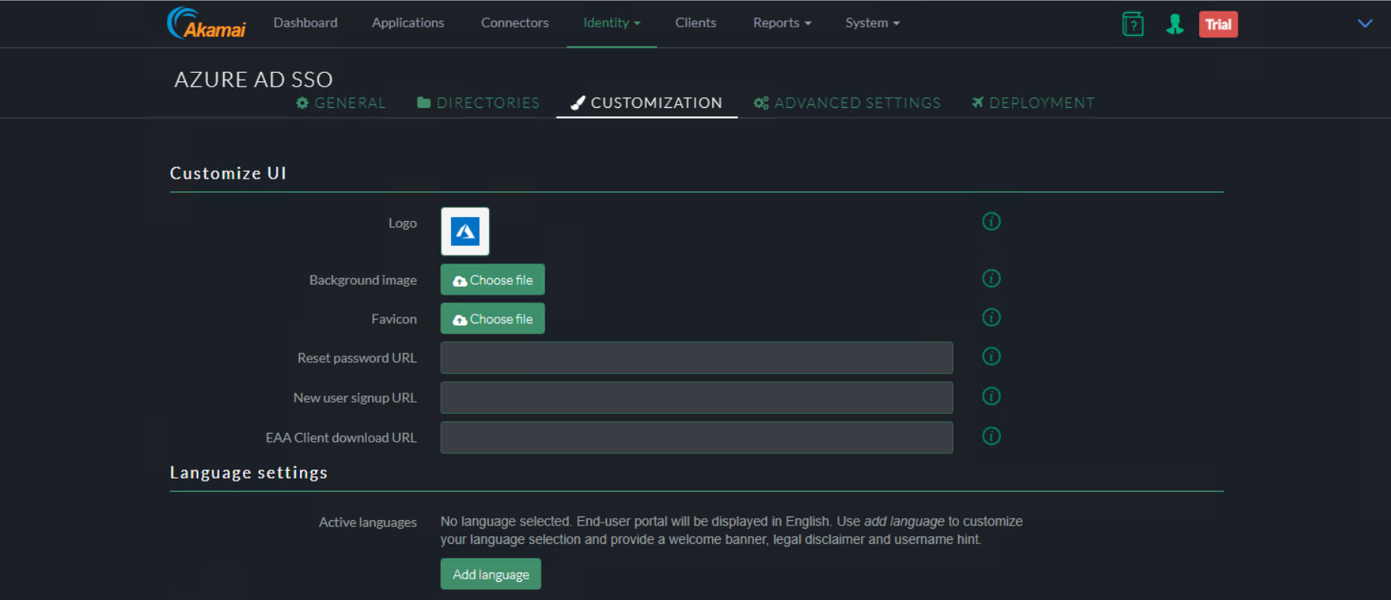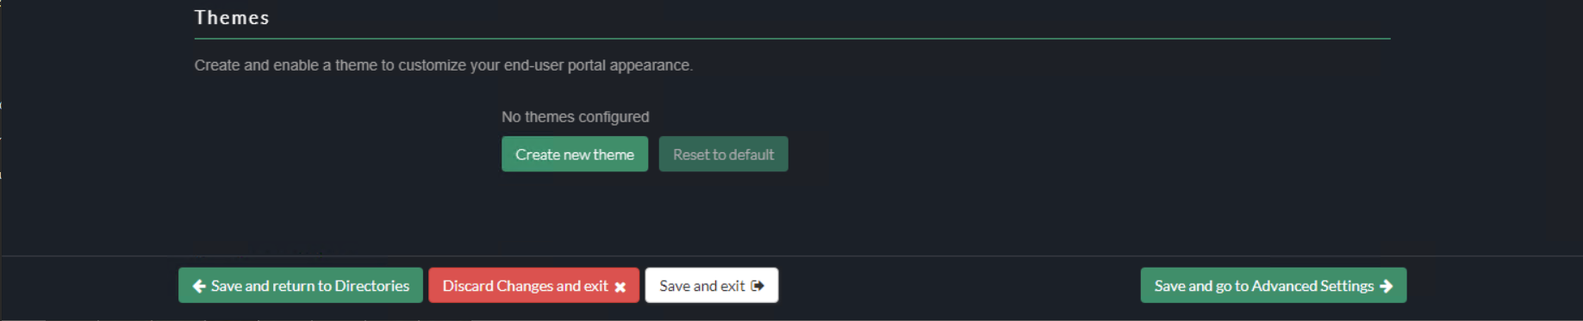

Advanced Settings

* Skip Advance settings / refer Akamai documentation for more details

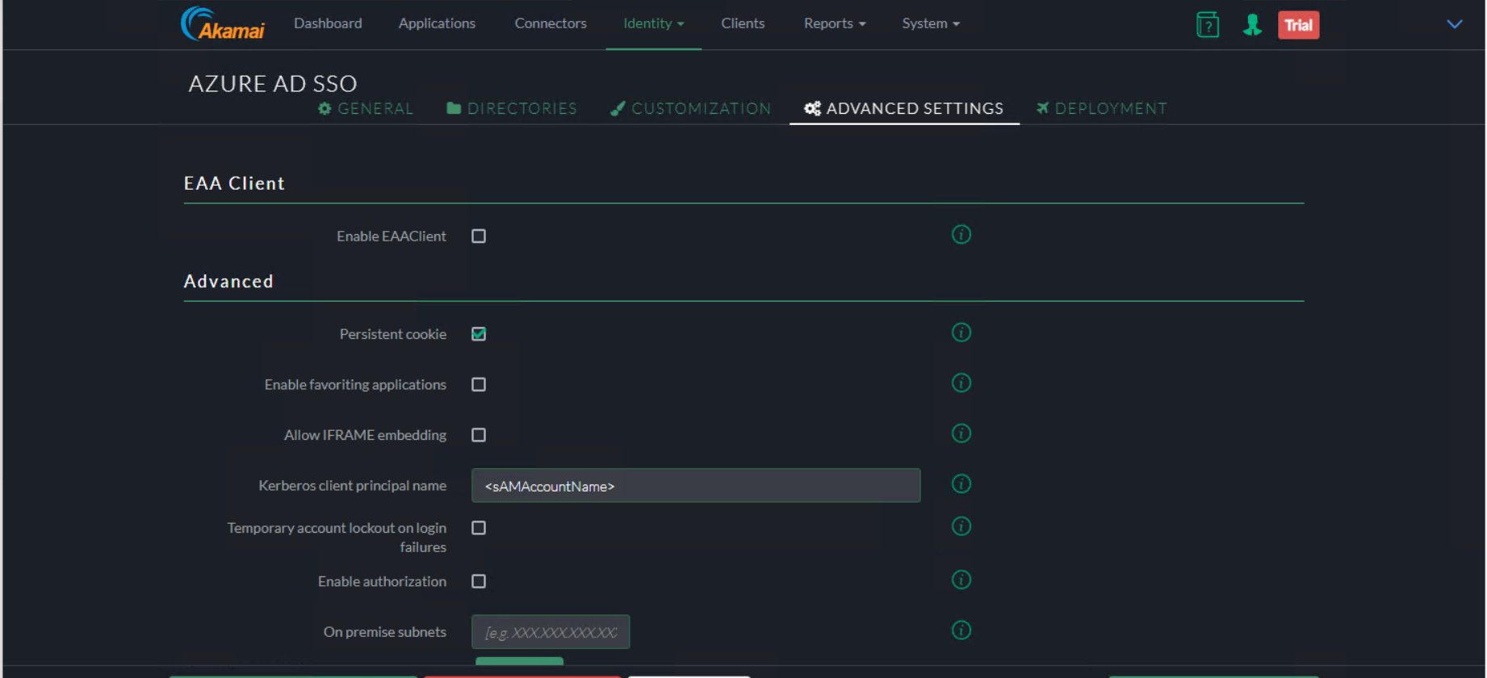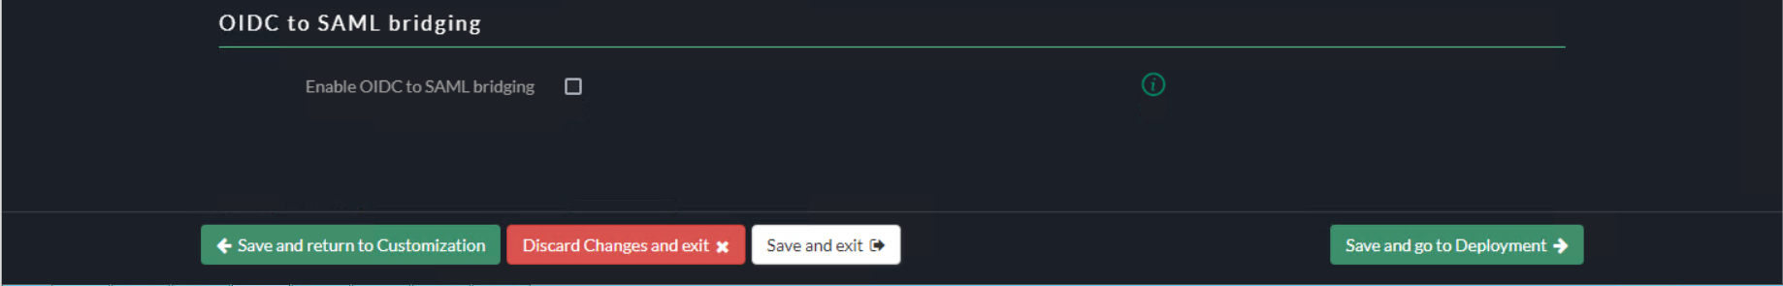

Deployment

* Click on Deploy Identity Provider

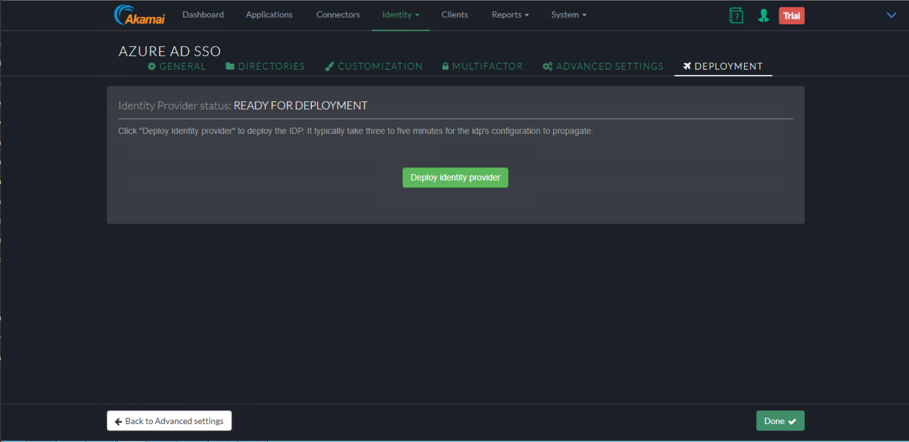

Verify the deployment was successful

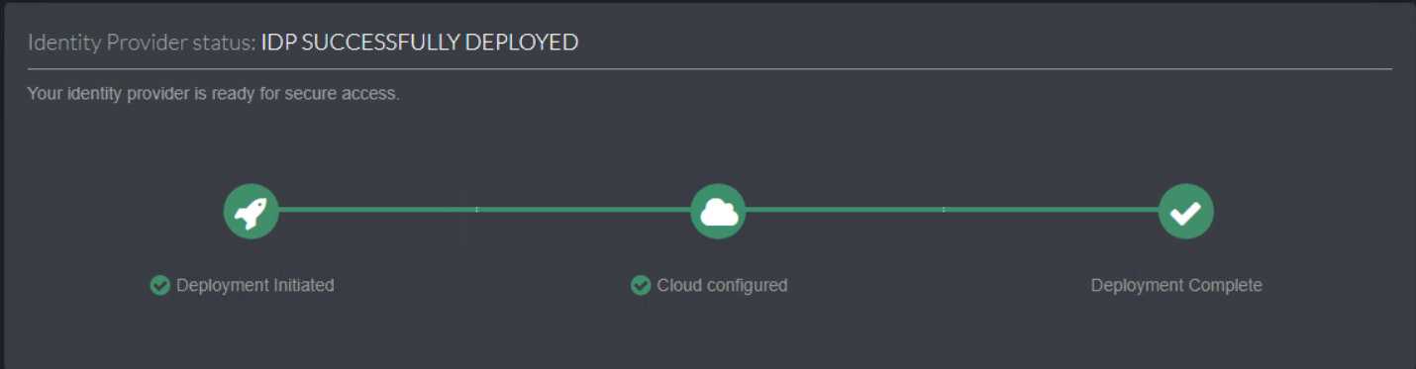

Assign Applications

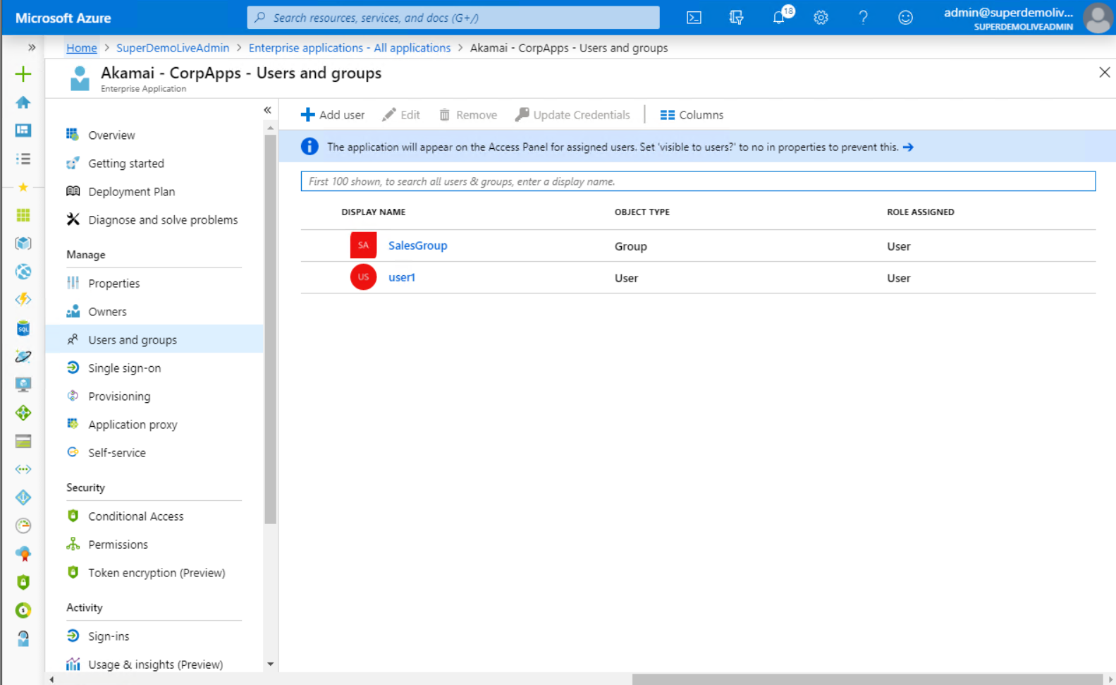

Conditional Access

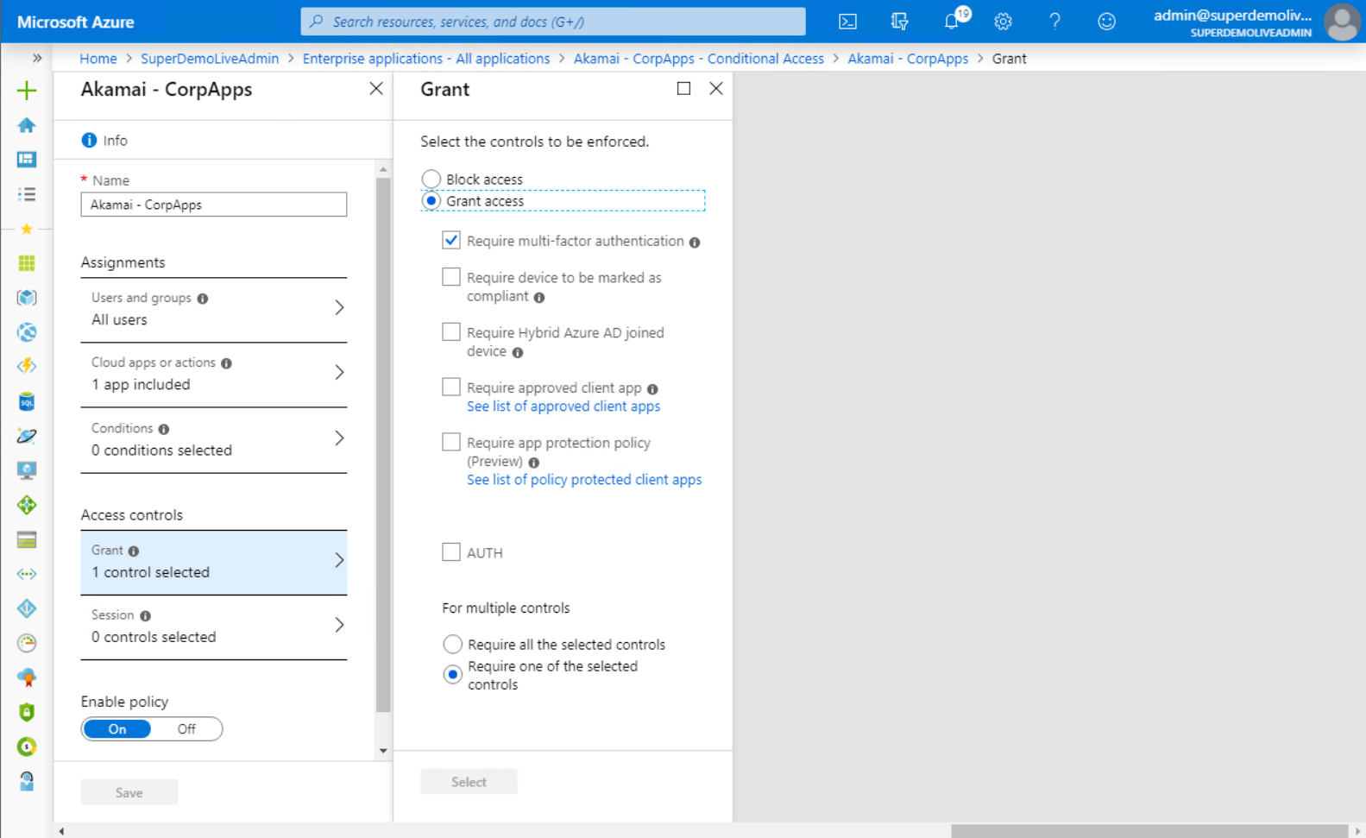

# **Header Based Authentication**

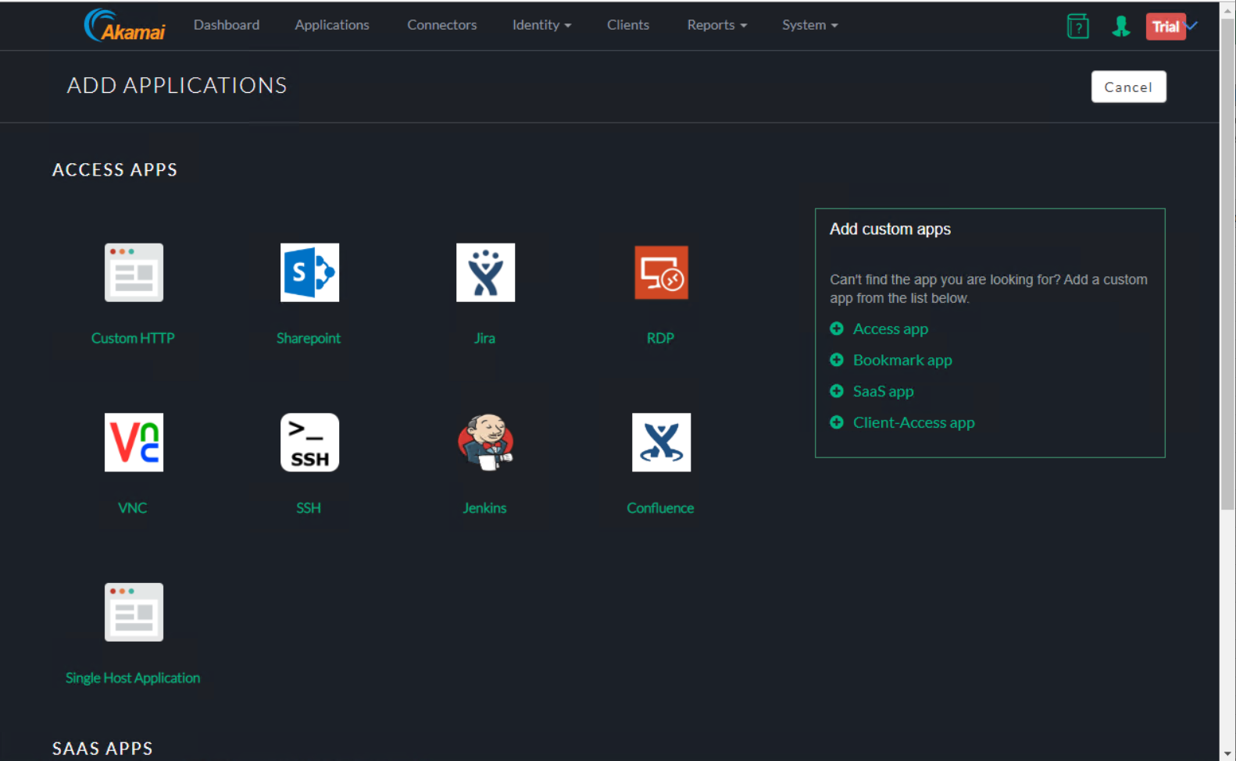

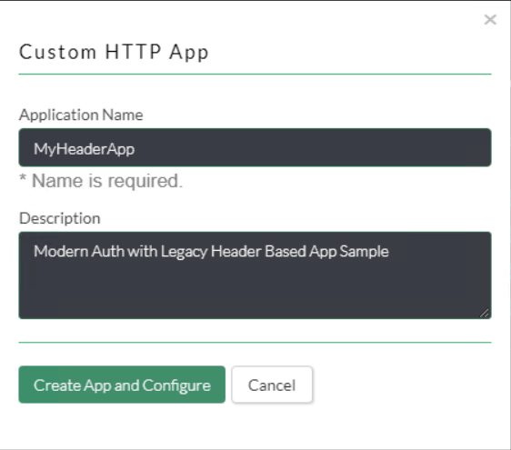

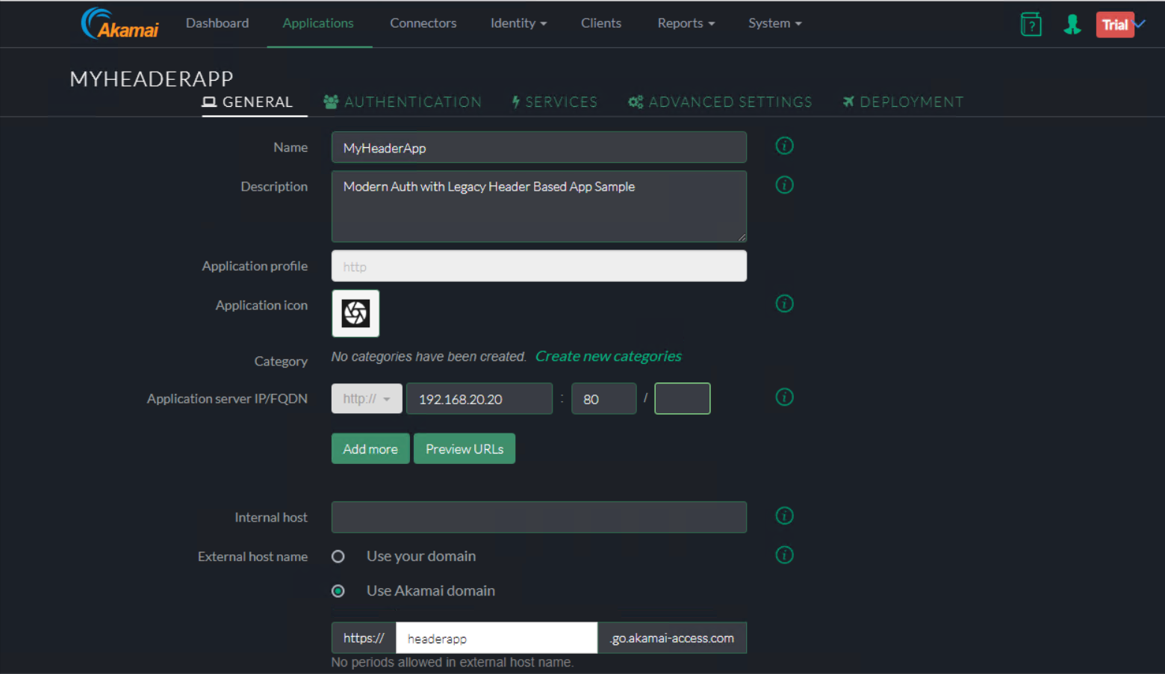

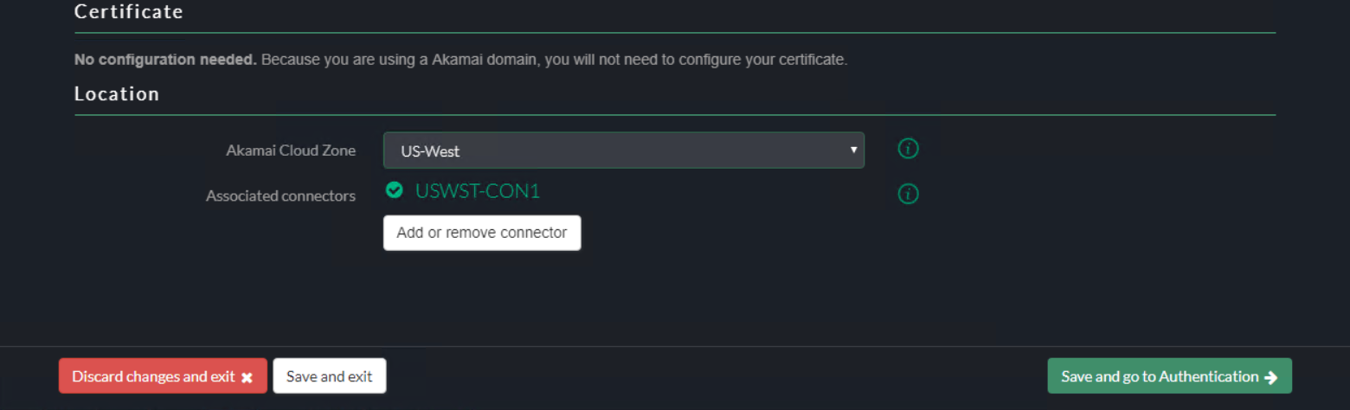

Authentication

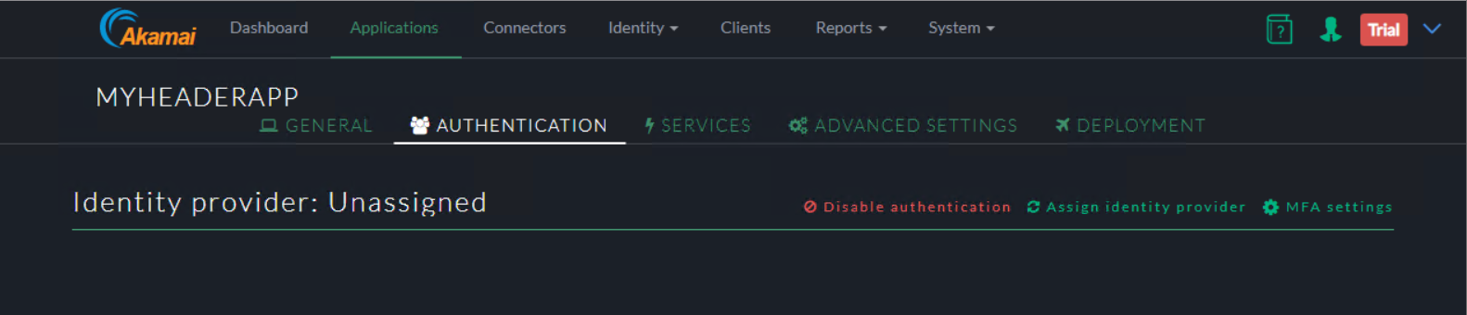

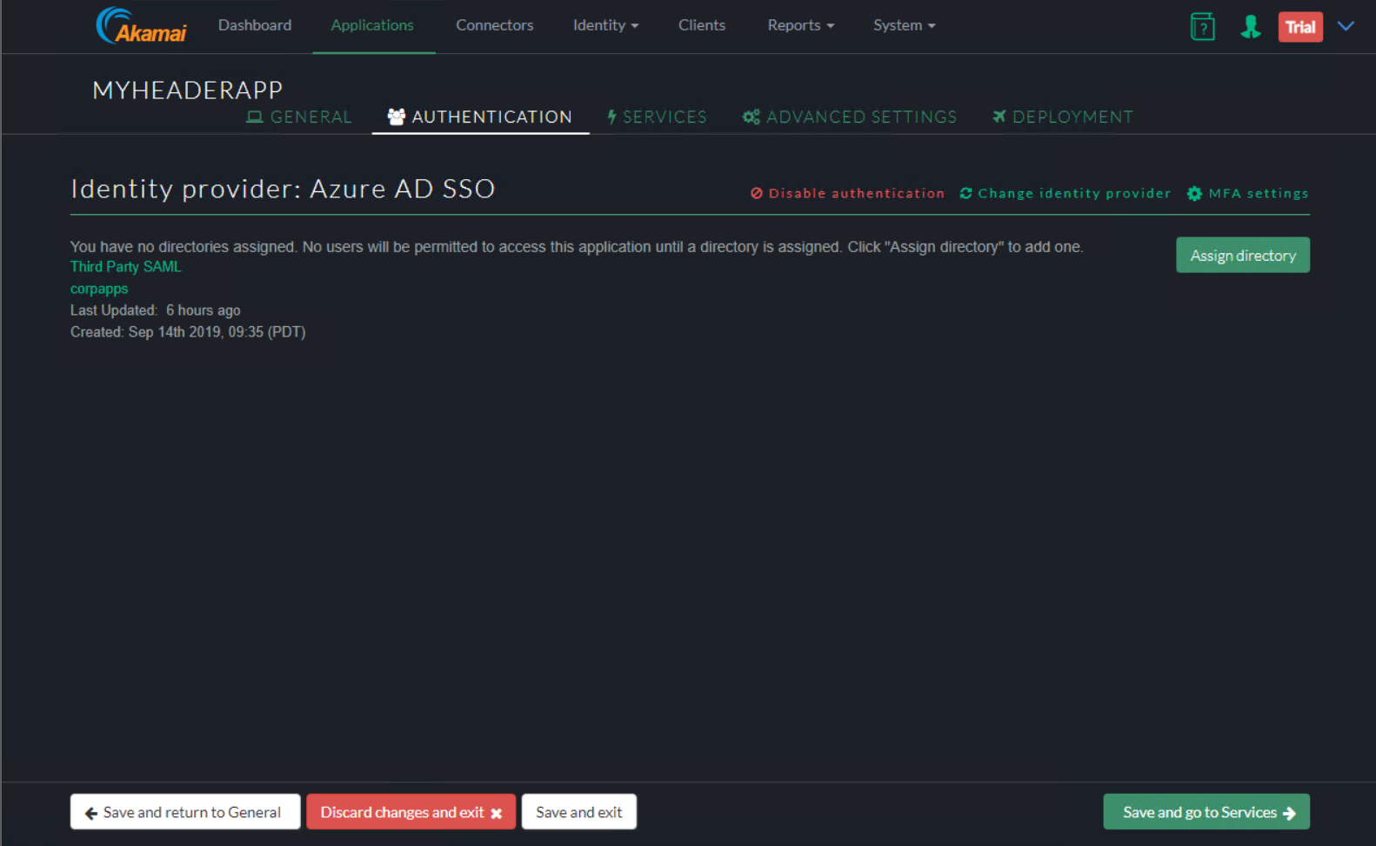

Services

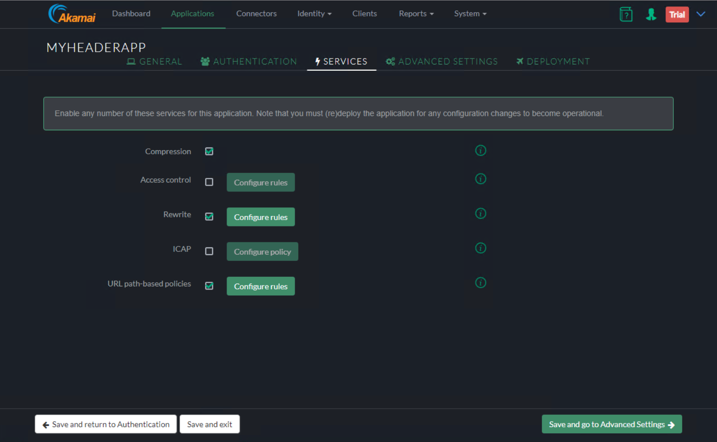

Advanced Settings

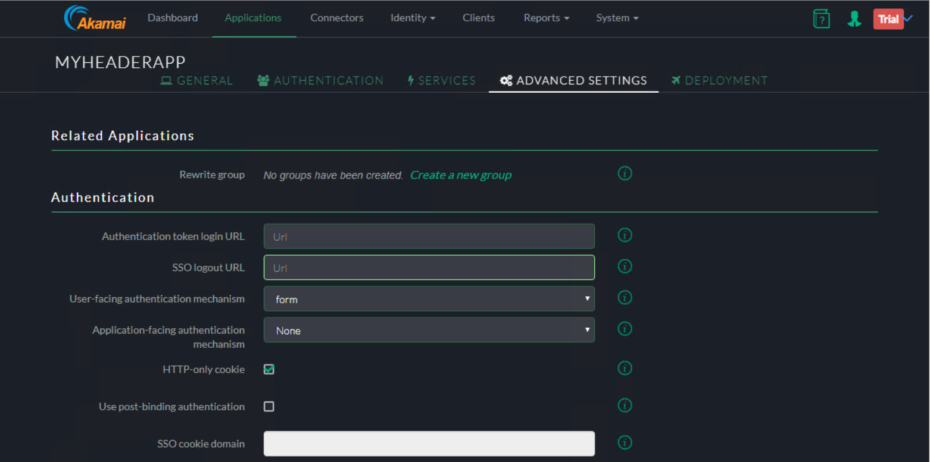

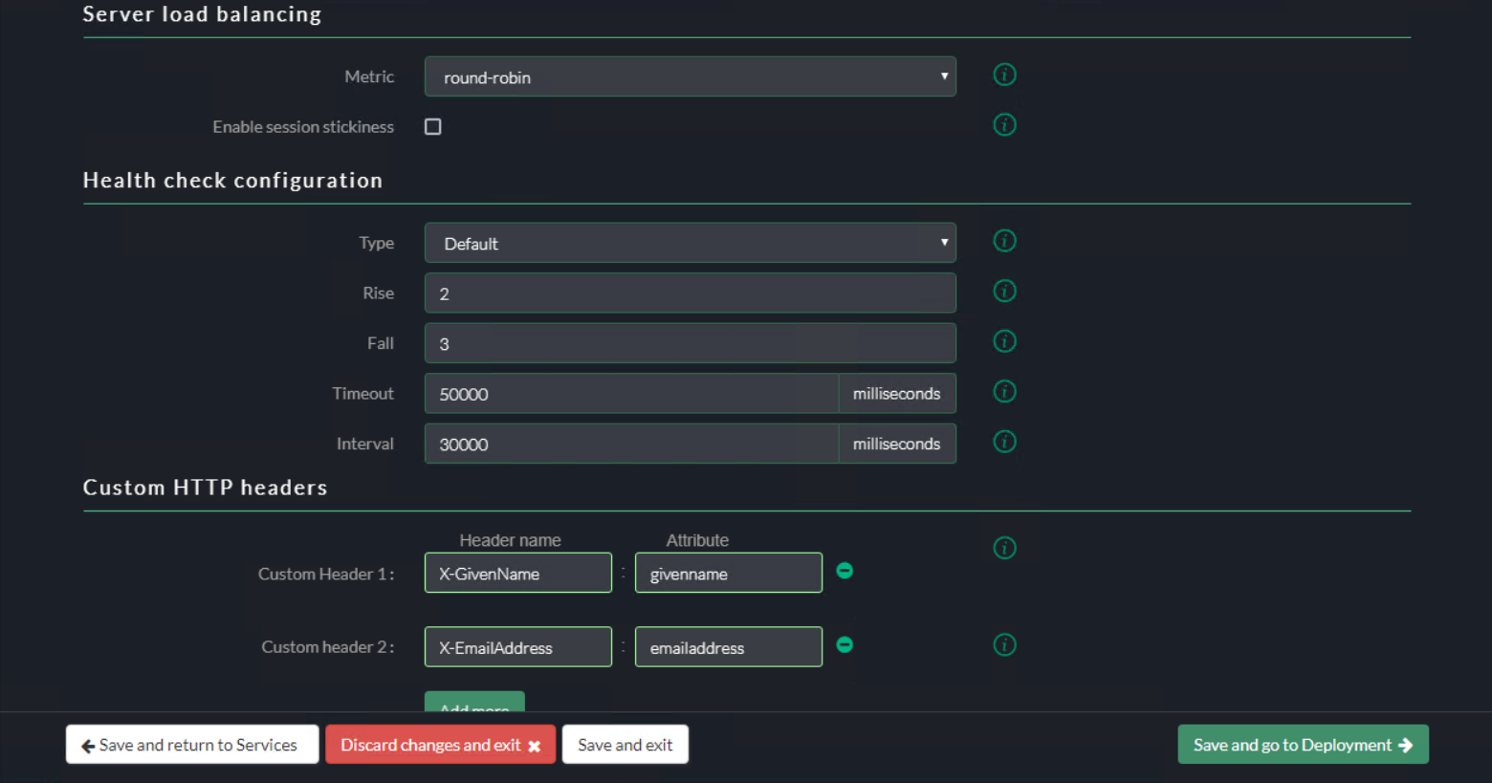

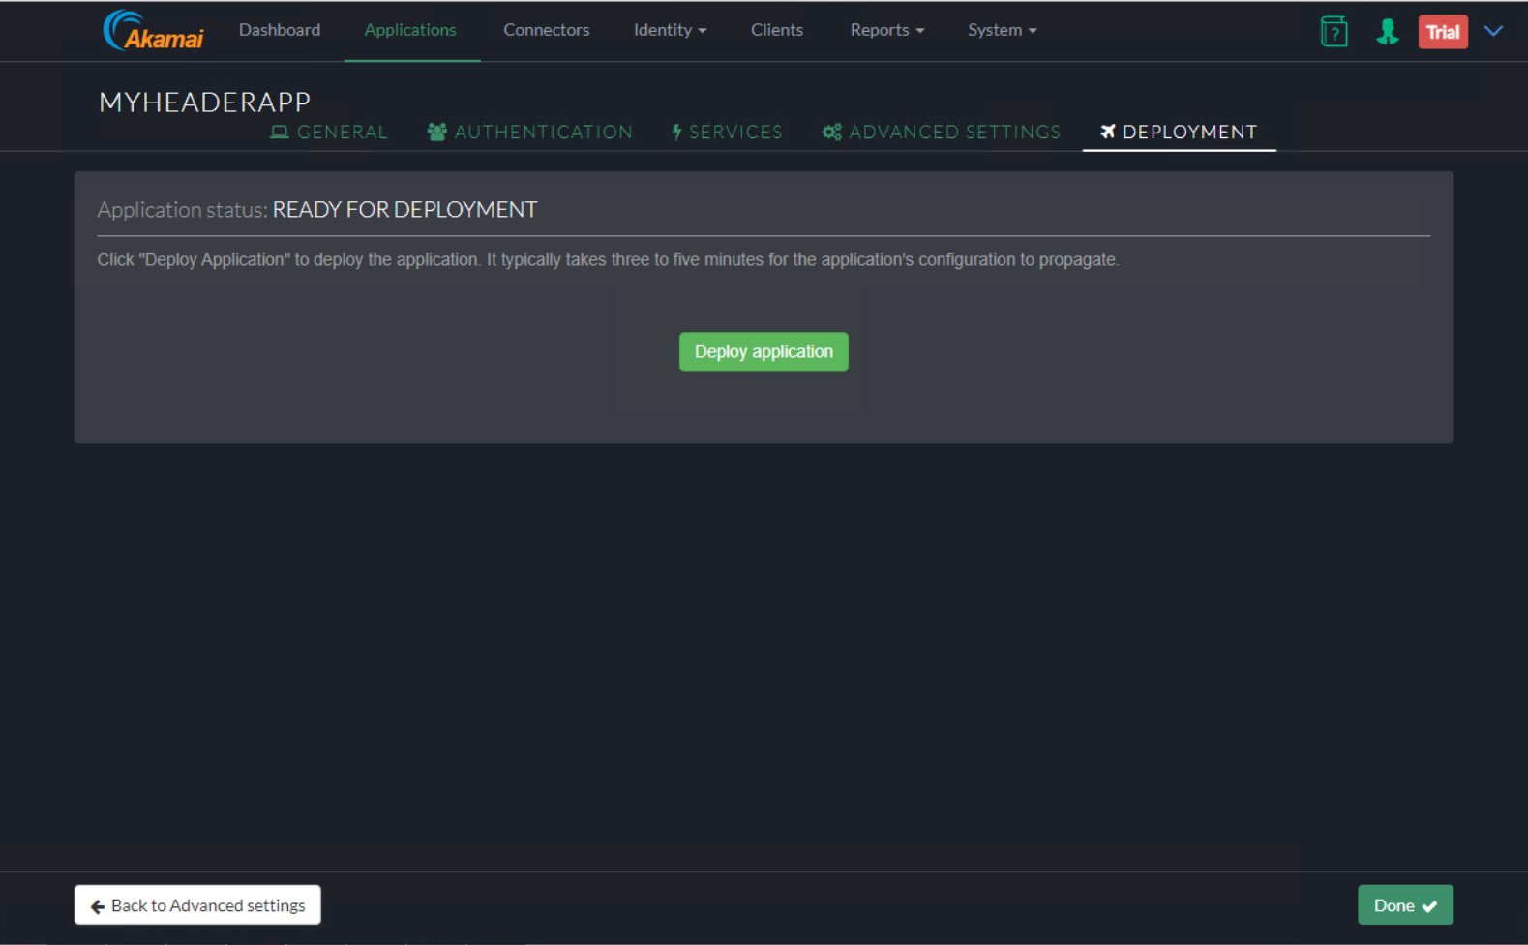

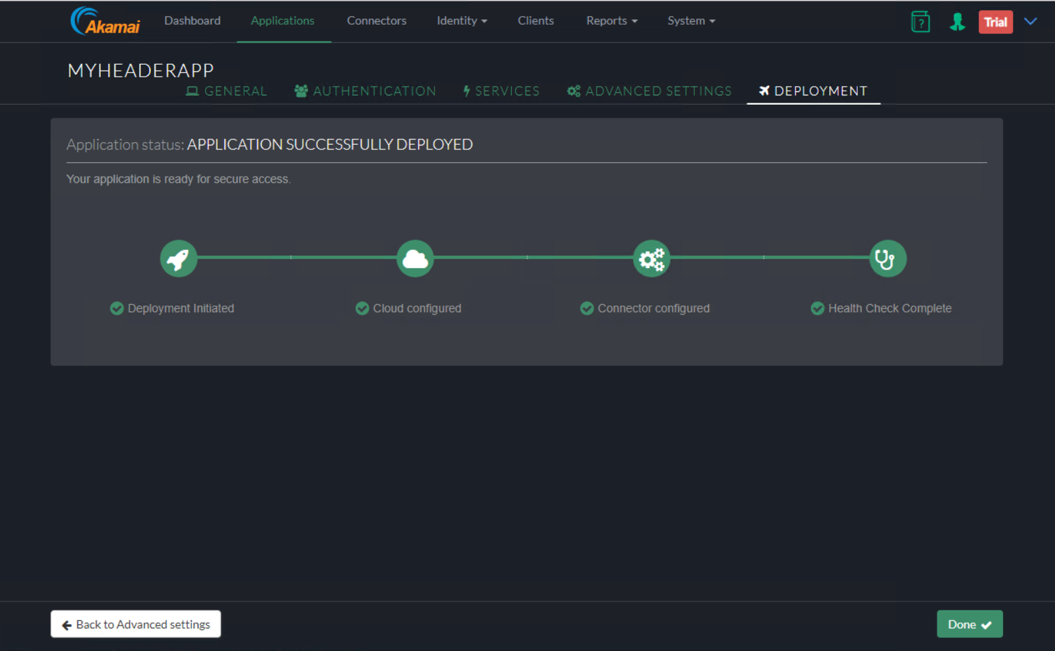

End-User Experience

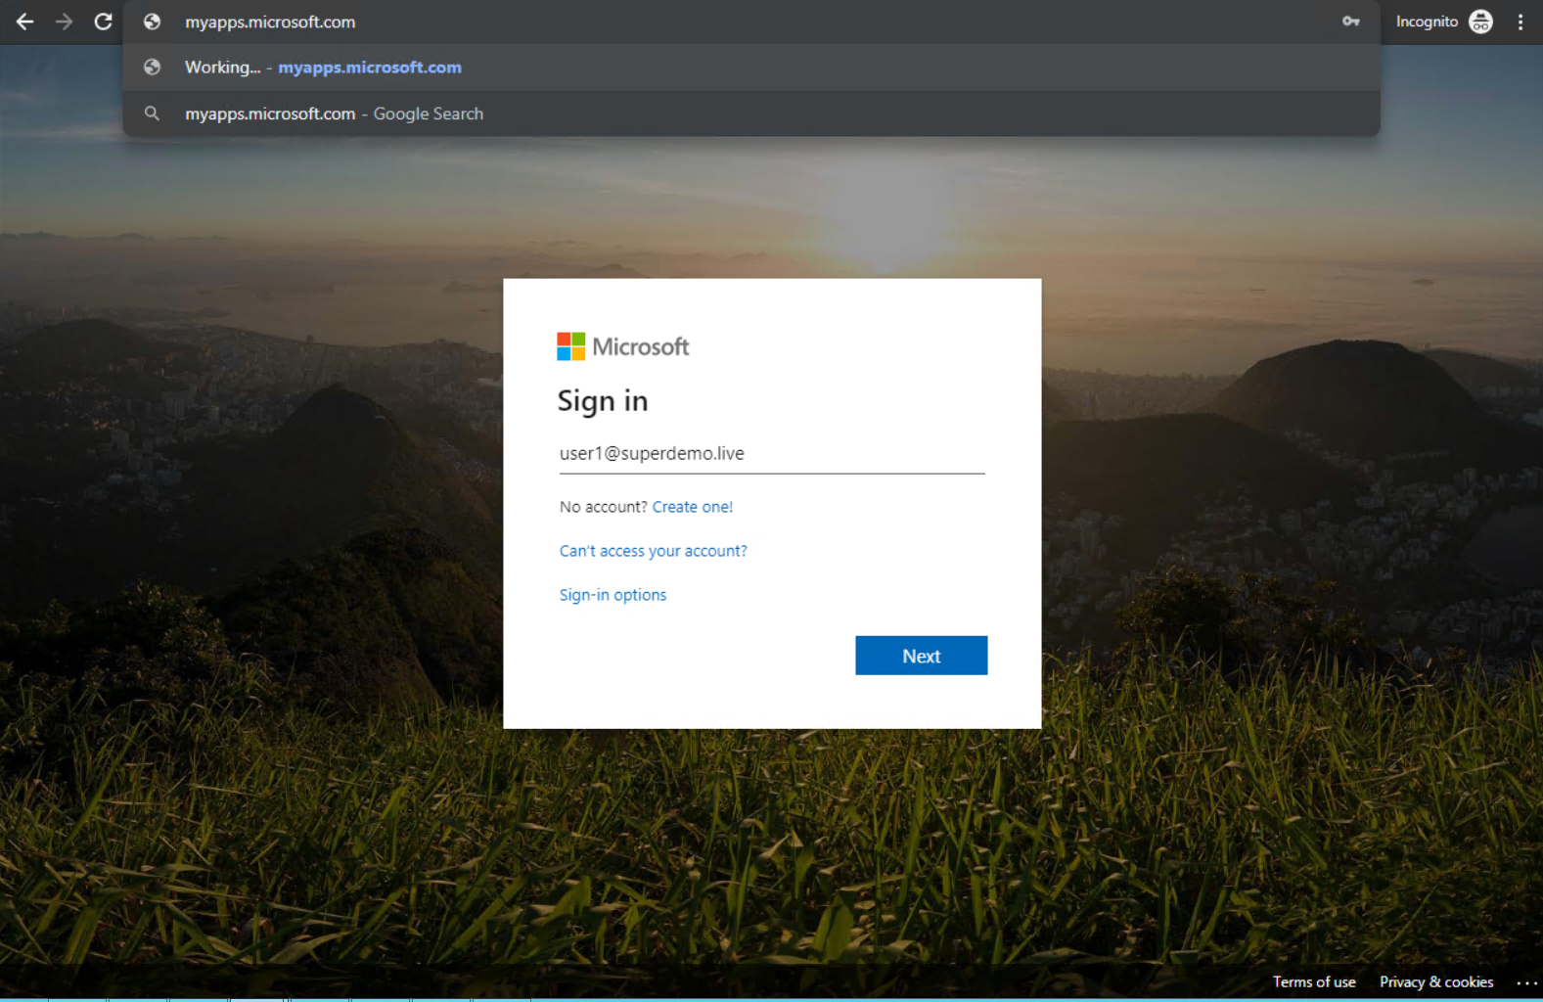

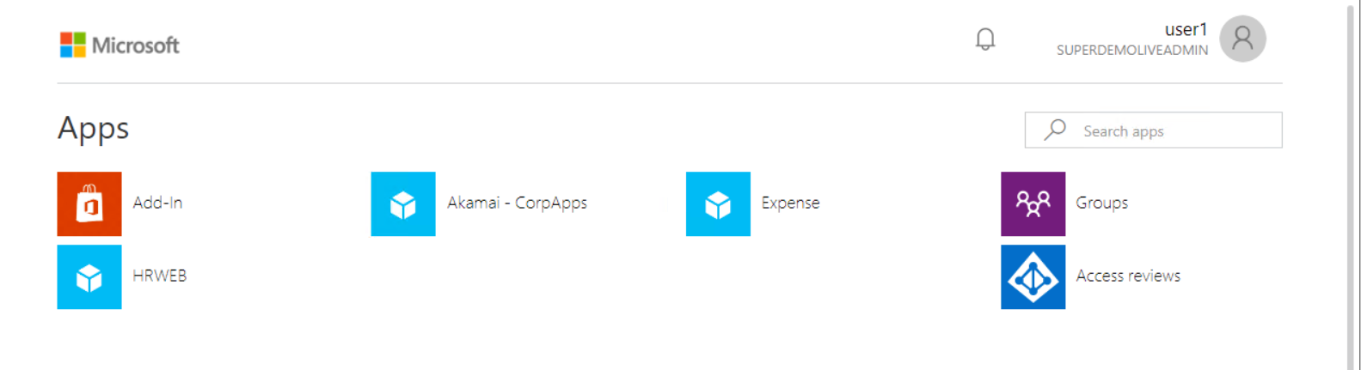

Conditional Access

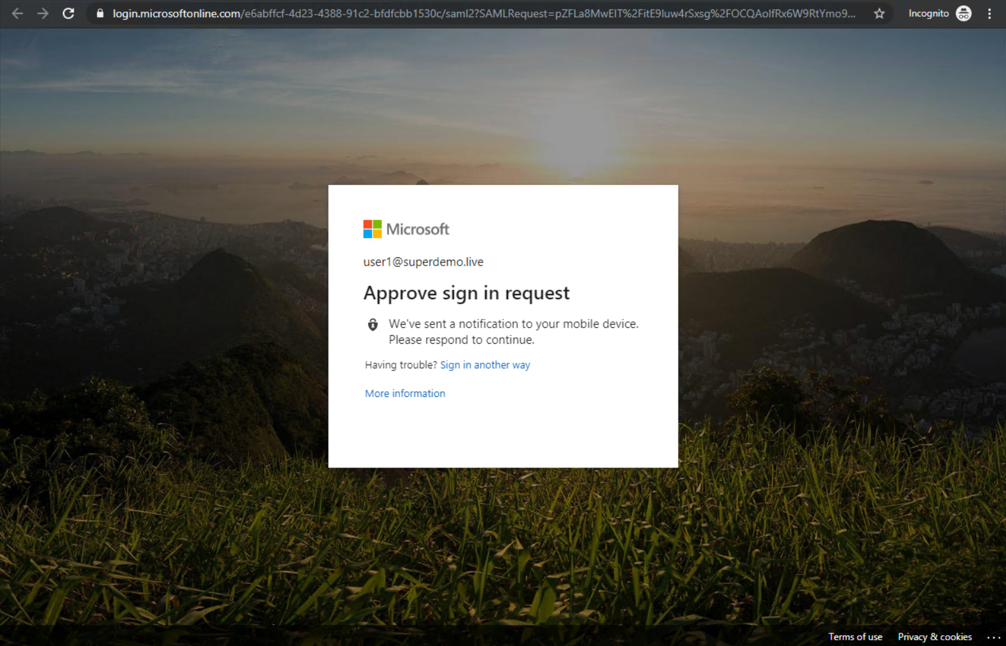

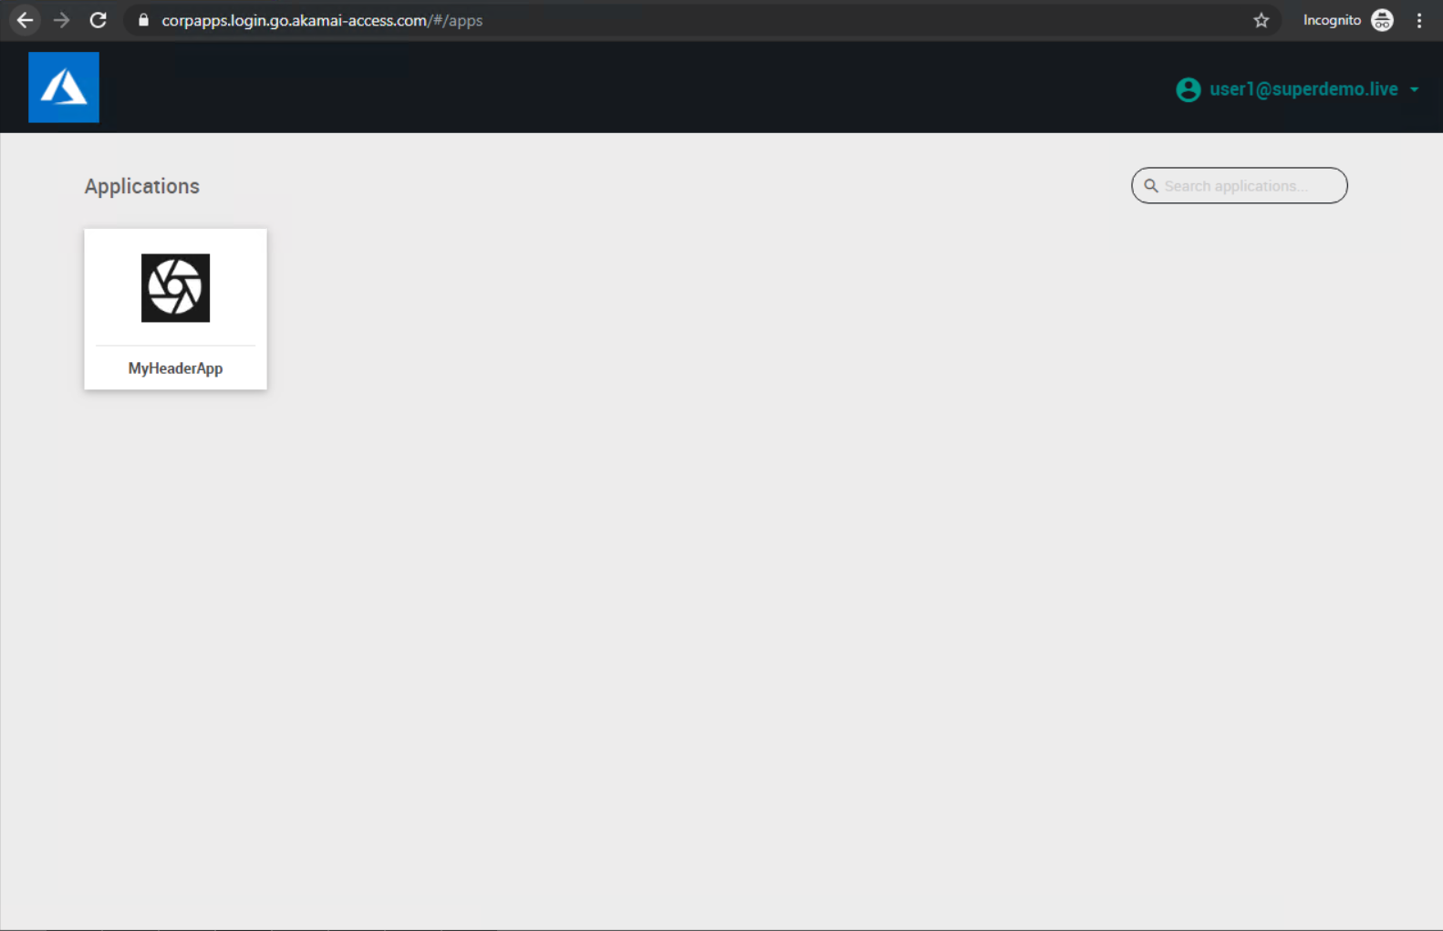

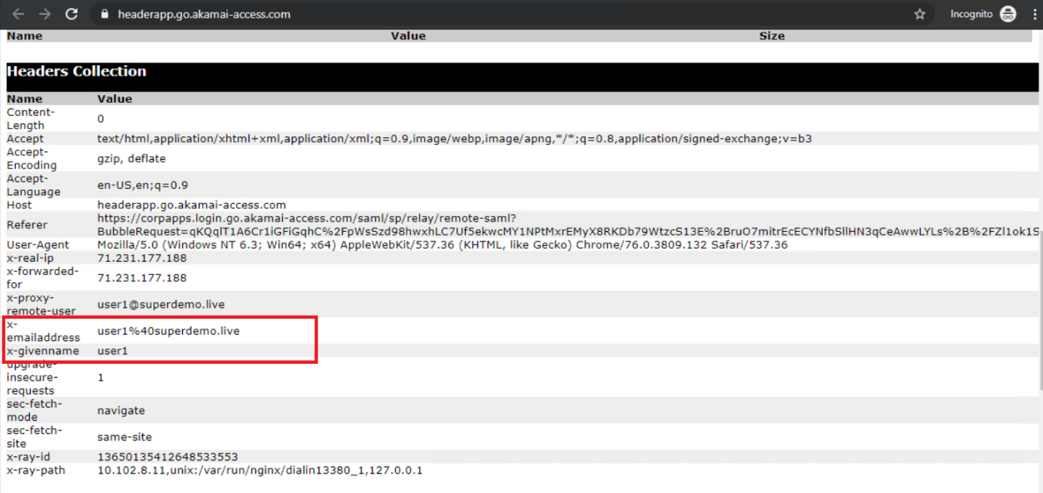

# **Remote Desktop**

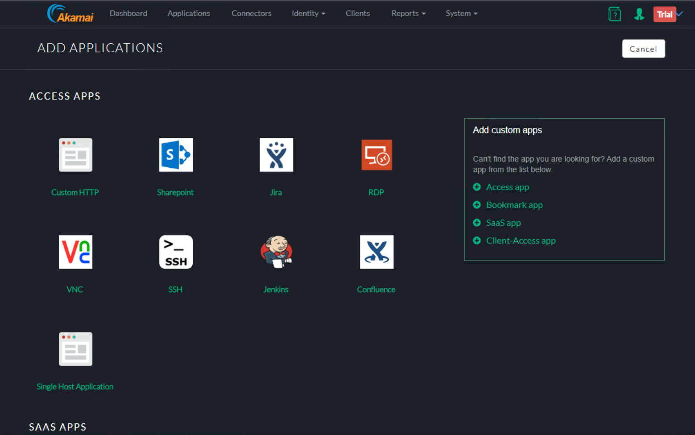

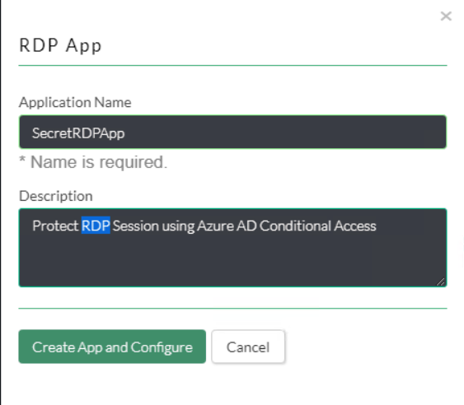

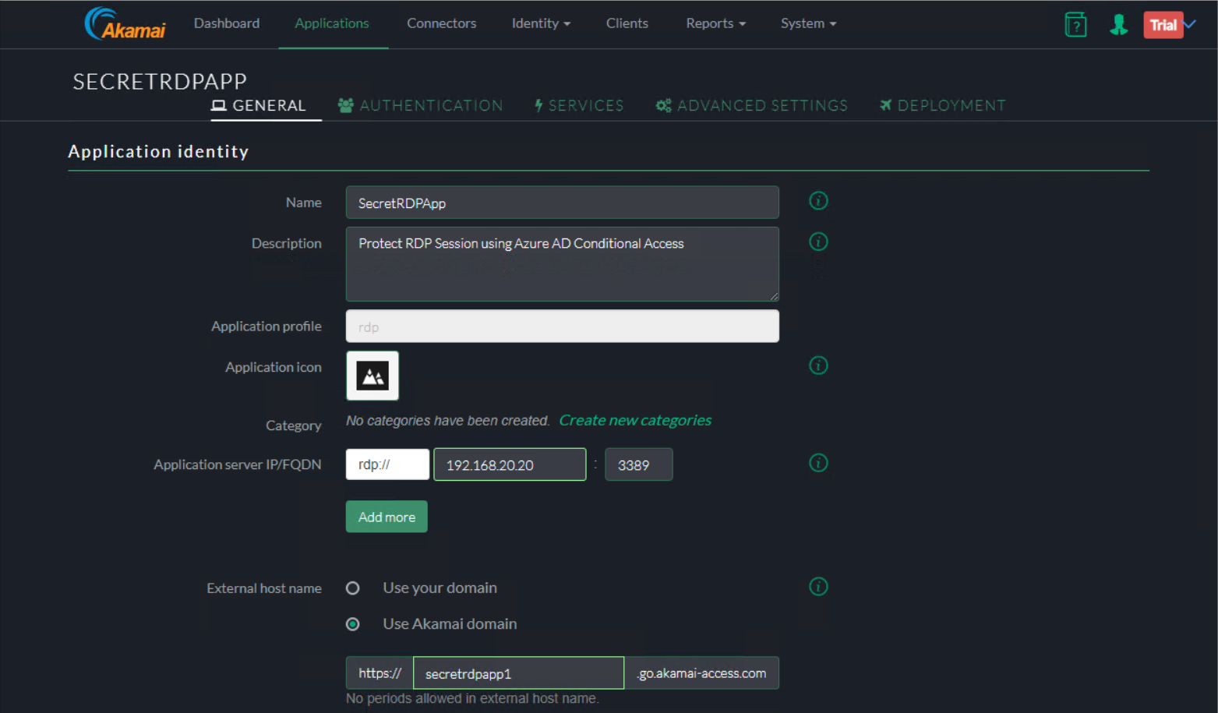

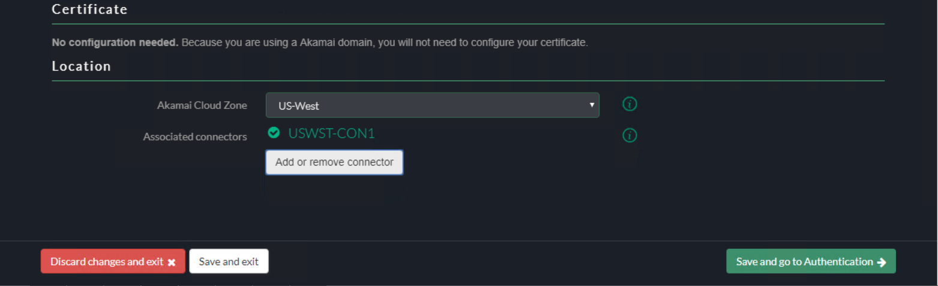

Authentication

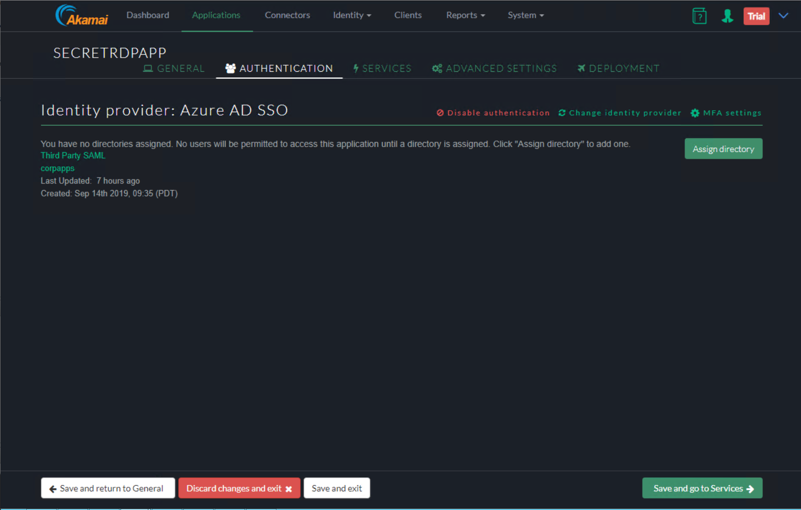

Services

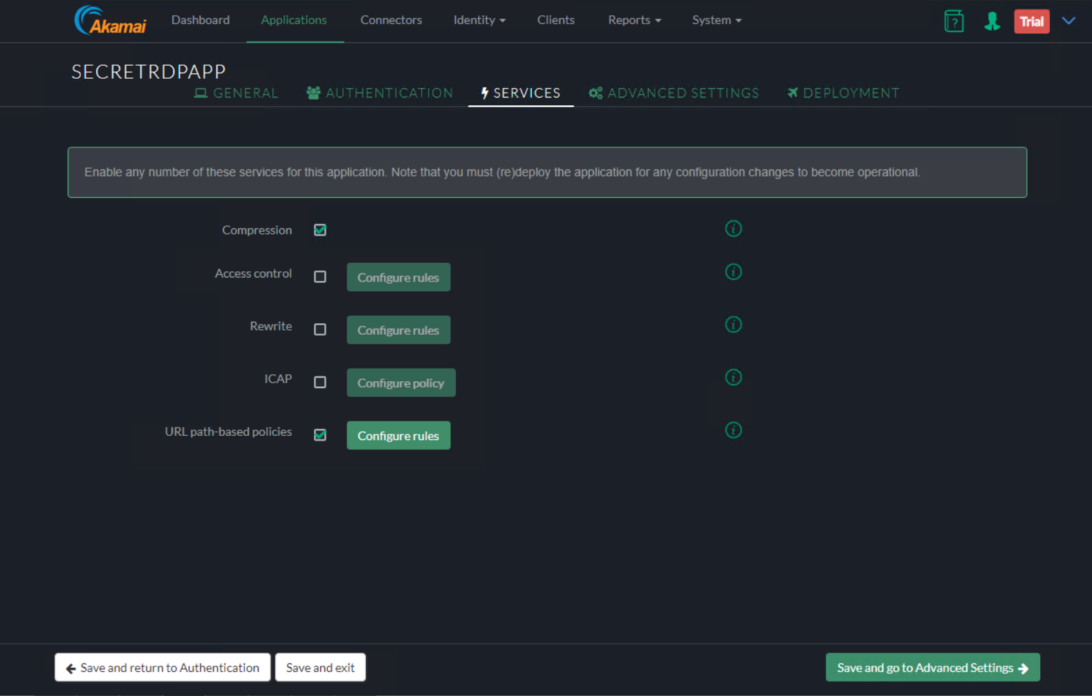

Advanced Settings

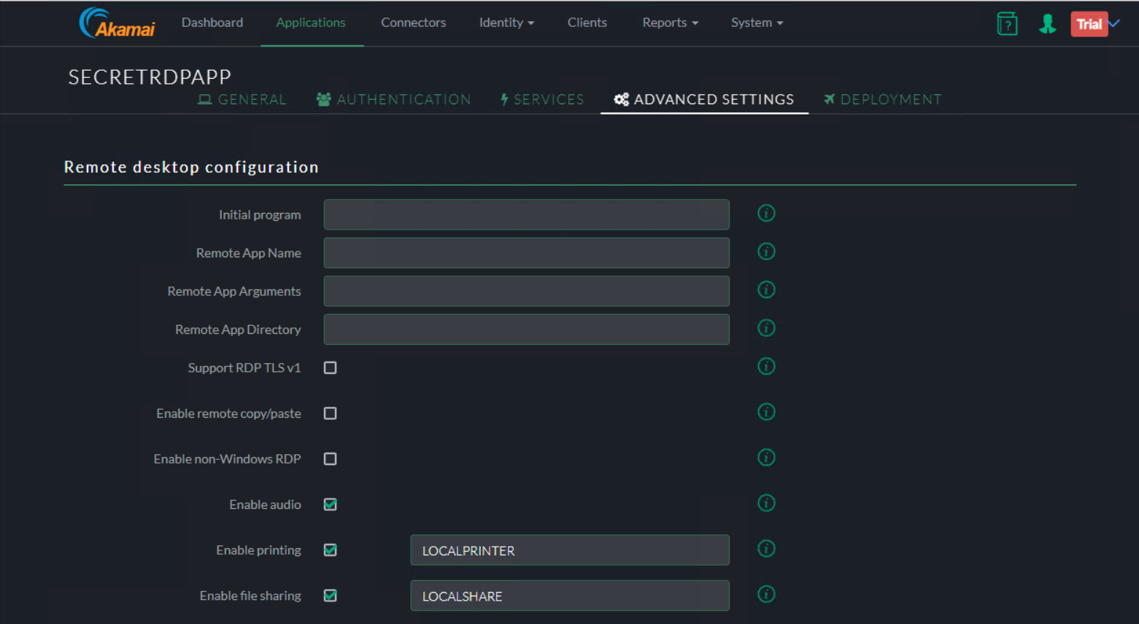

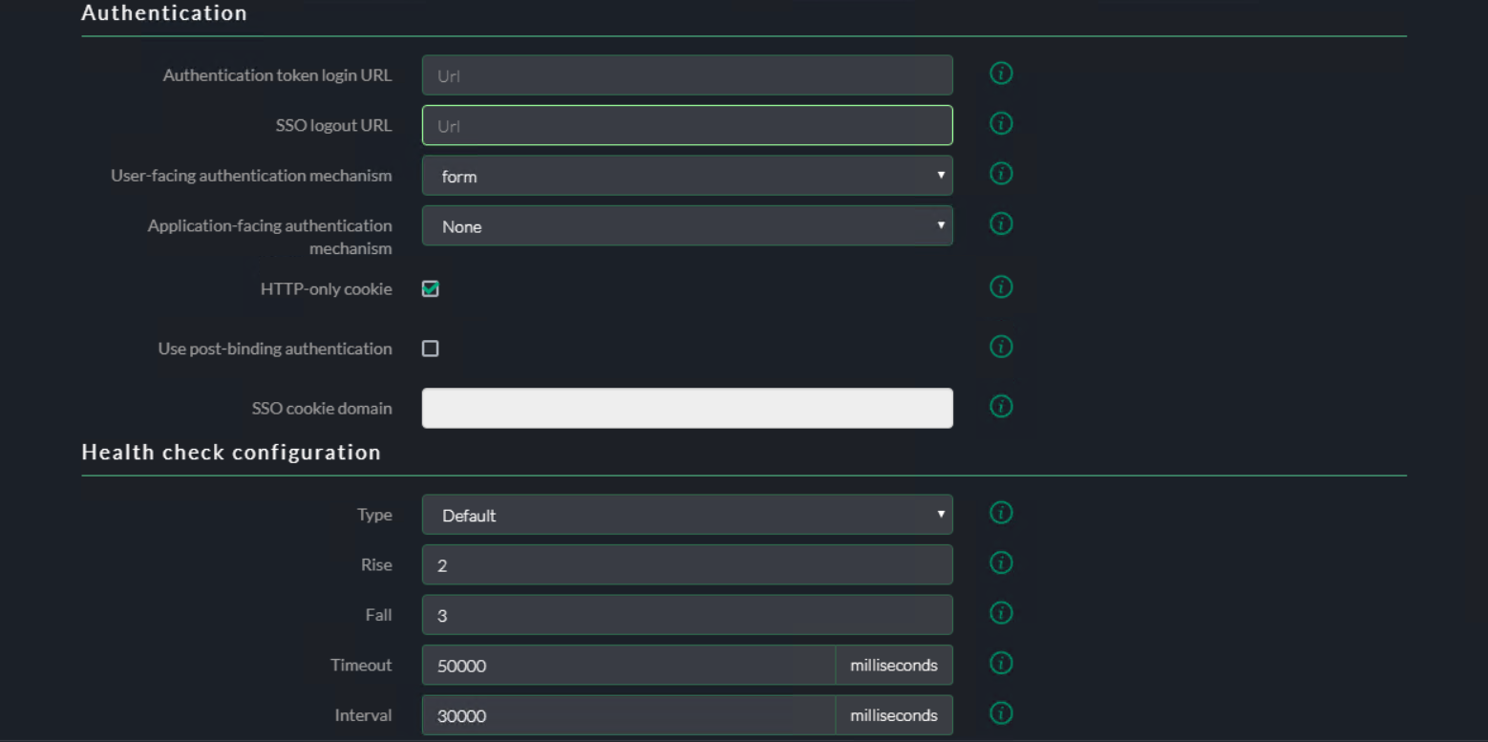

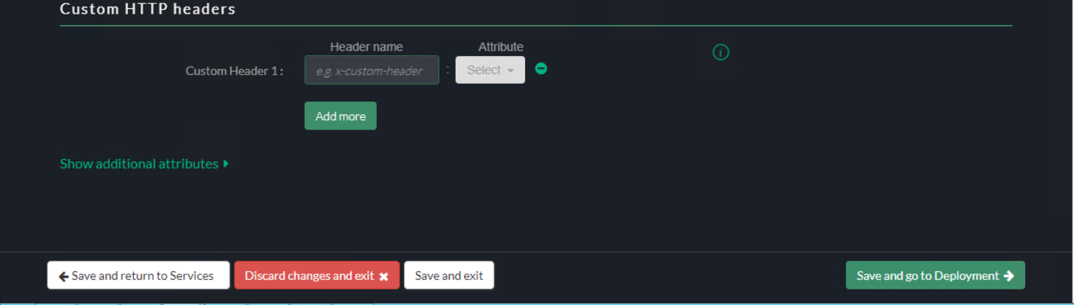

User Experience

End-User Experience



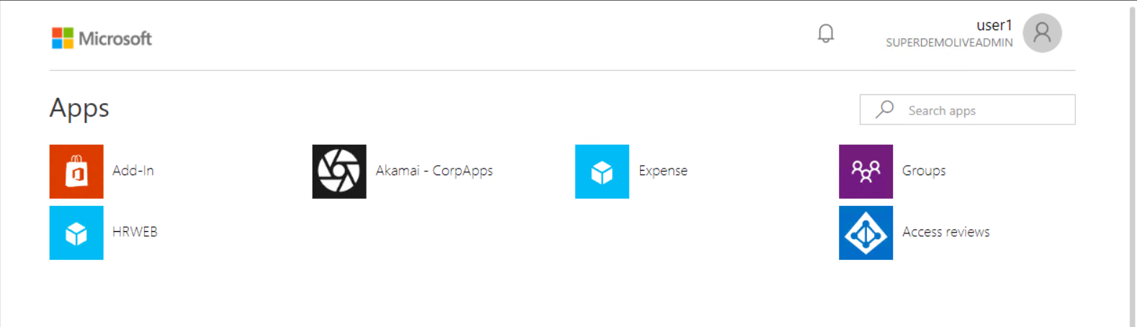

Conditional Access



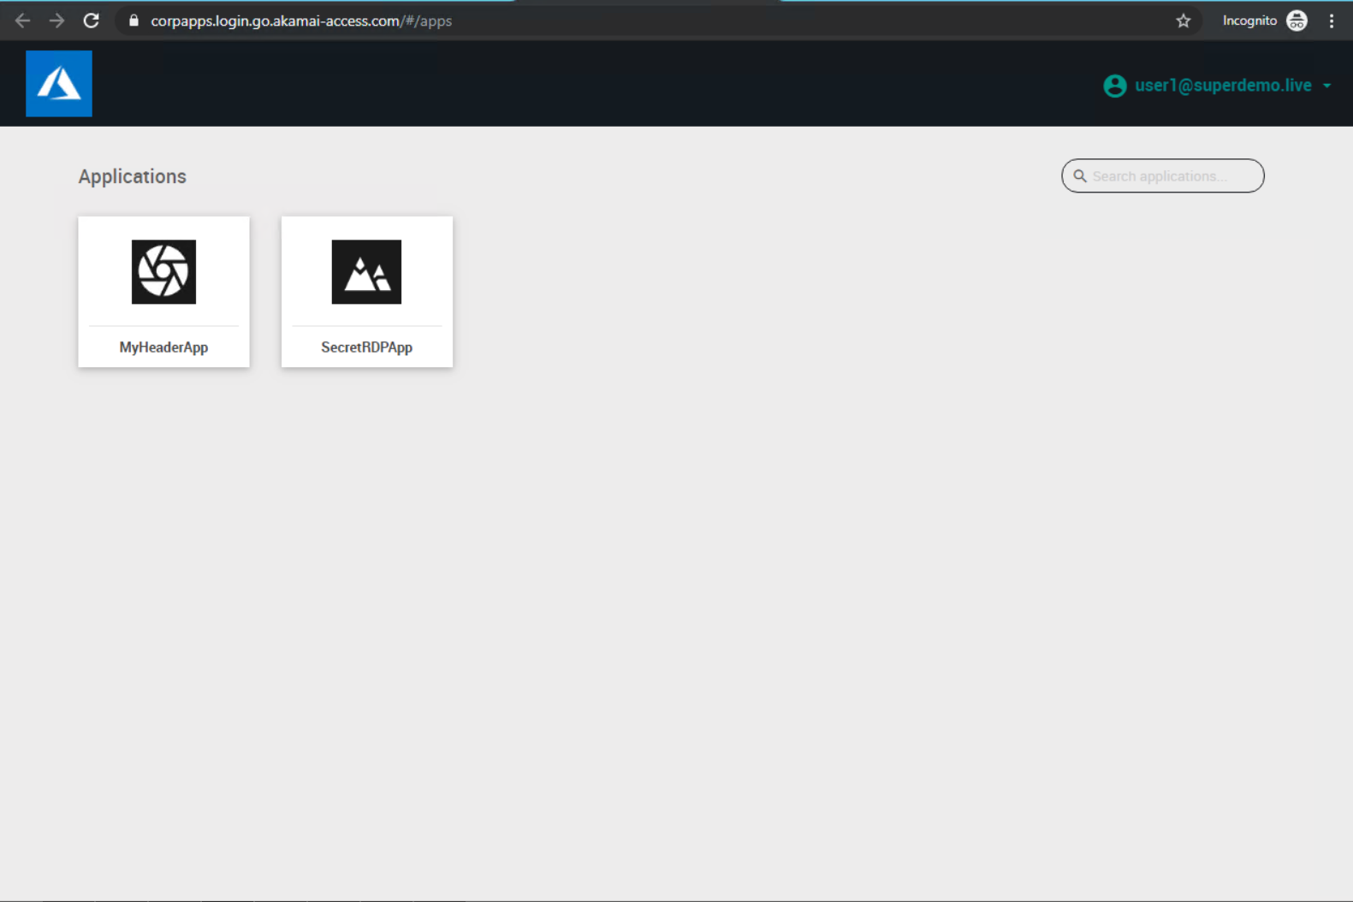

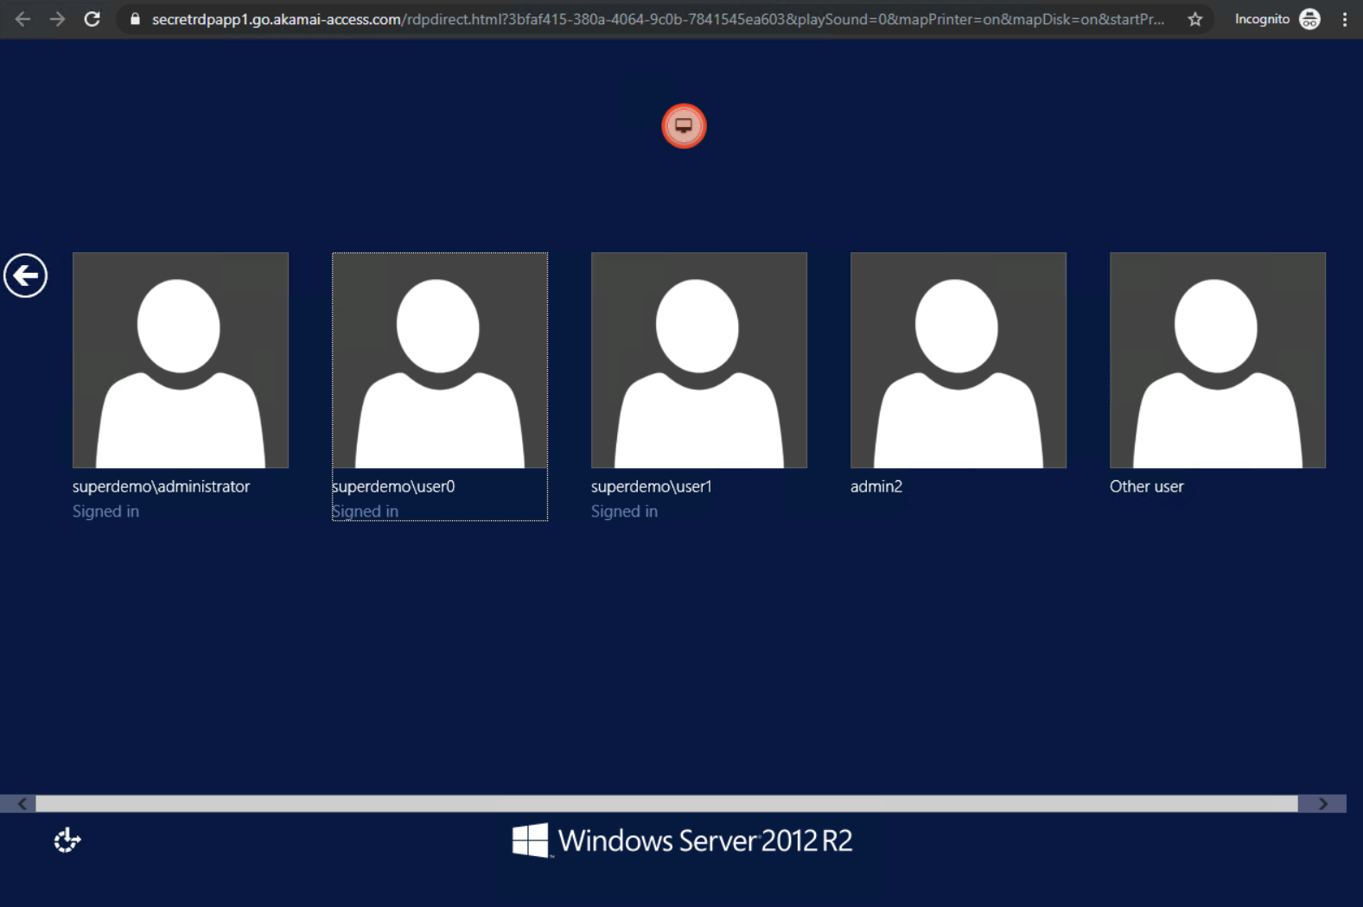

Alternatively, you can also directly Type the RDP Application URL

# **Deployment**

# **SSH**

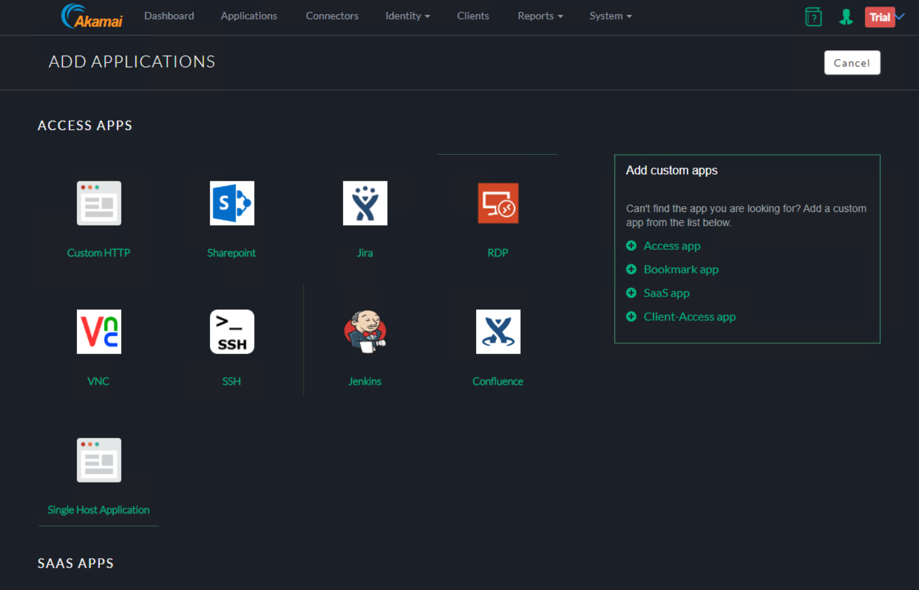

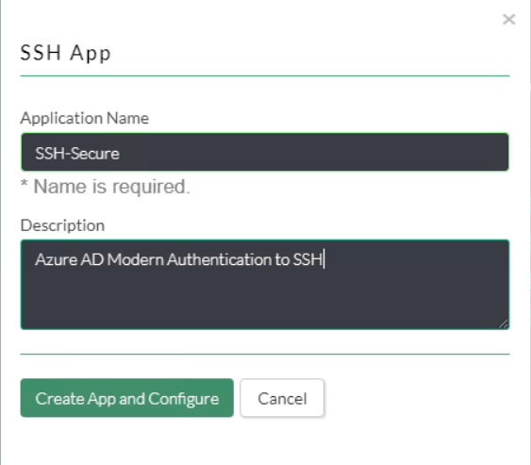

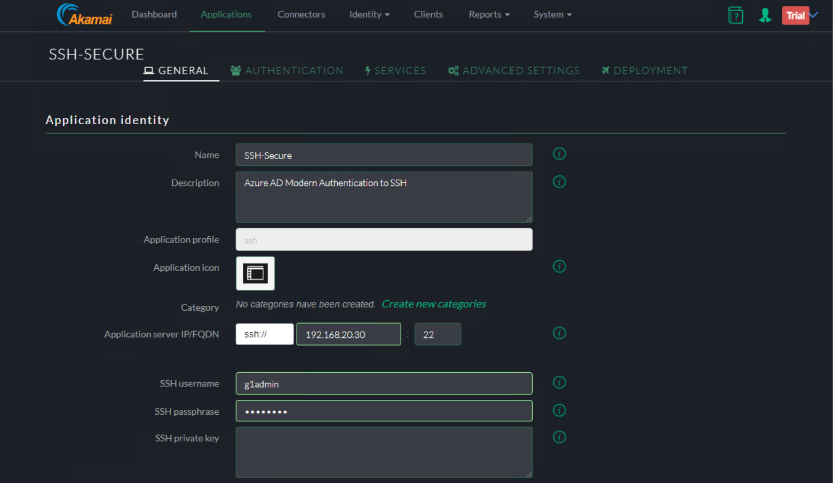 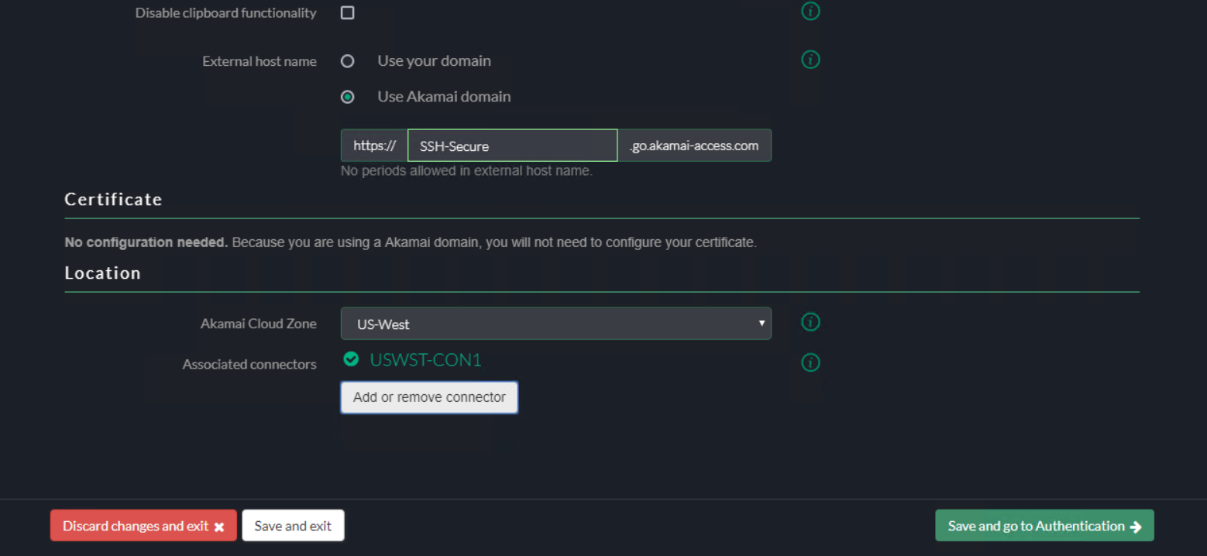

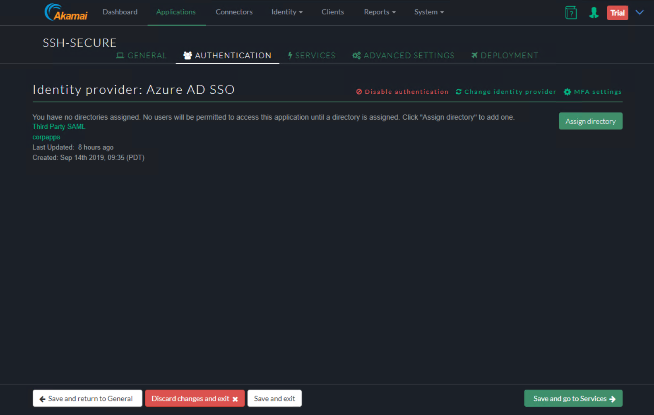

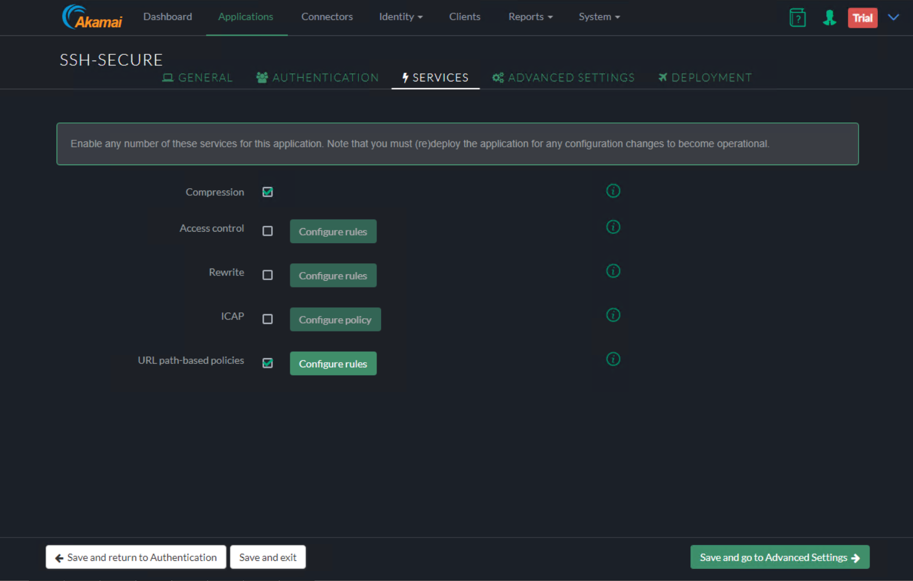

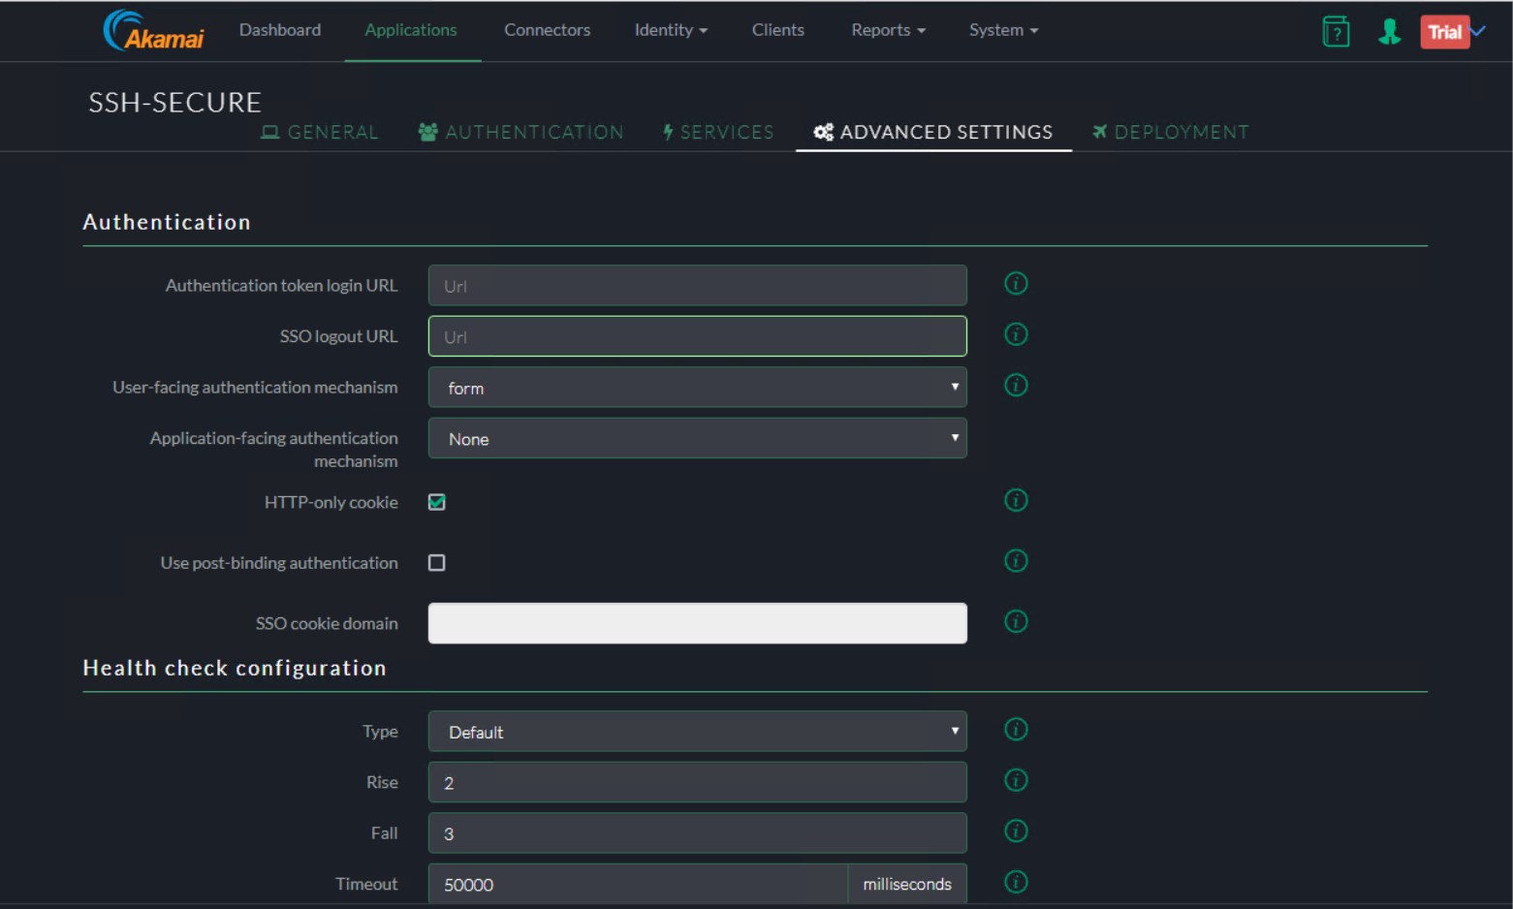

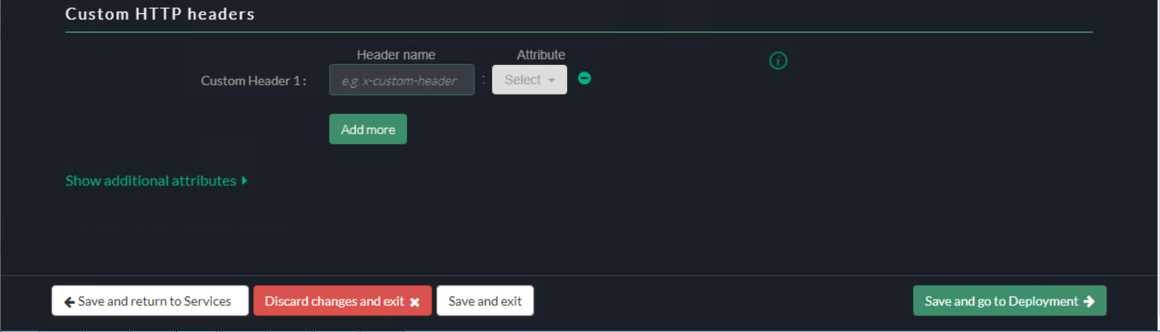

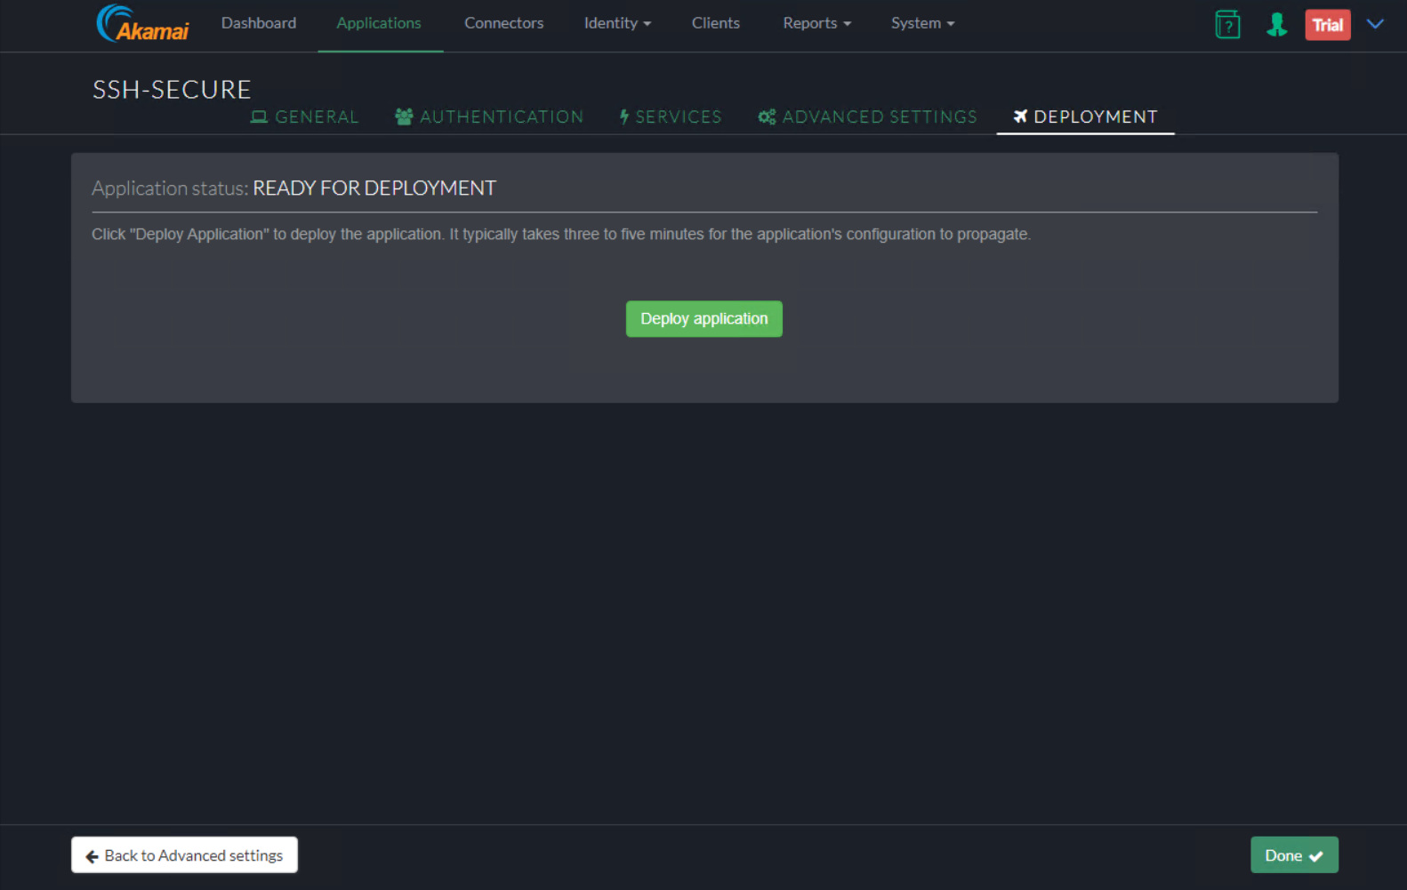

User Experience

End-User Experience





Conditional Access



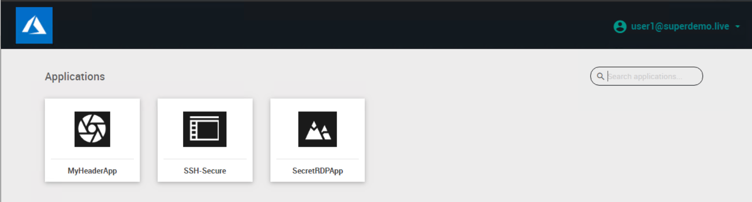

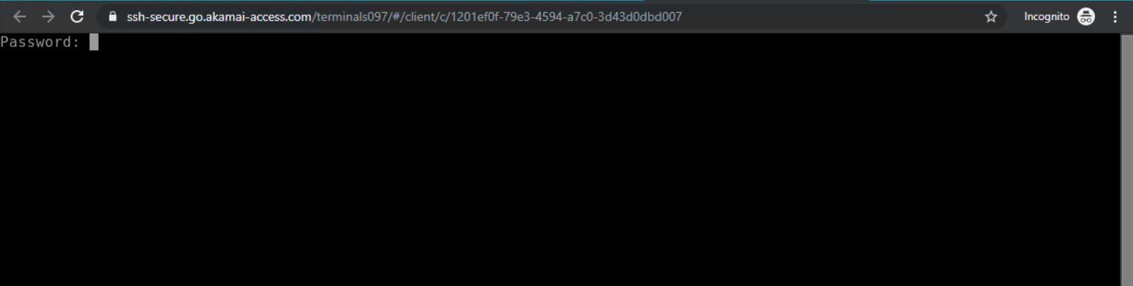

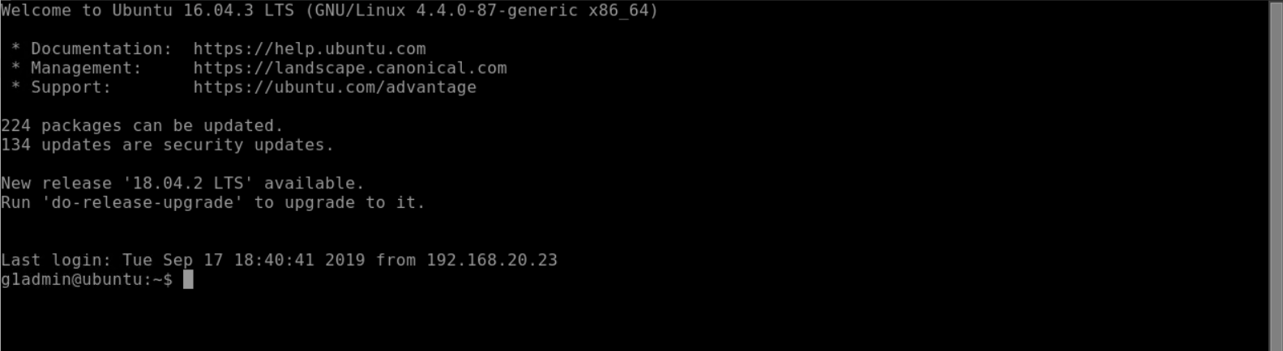

# **Kerberos Authentication**

In the below example we will publish an Internal web server <http://frp-app1.superdemo.live> and enable SSO using KCD

**General Tab**

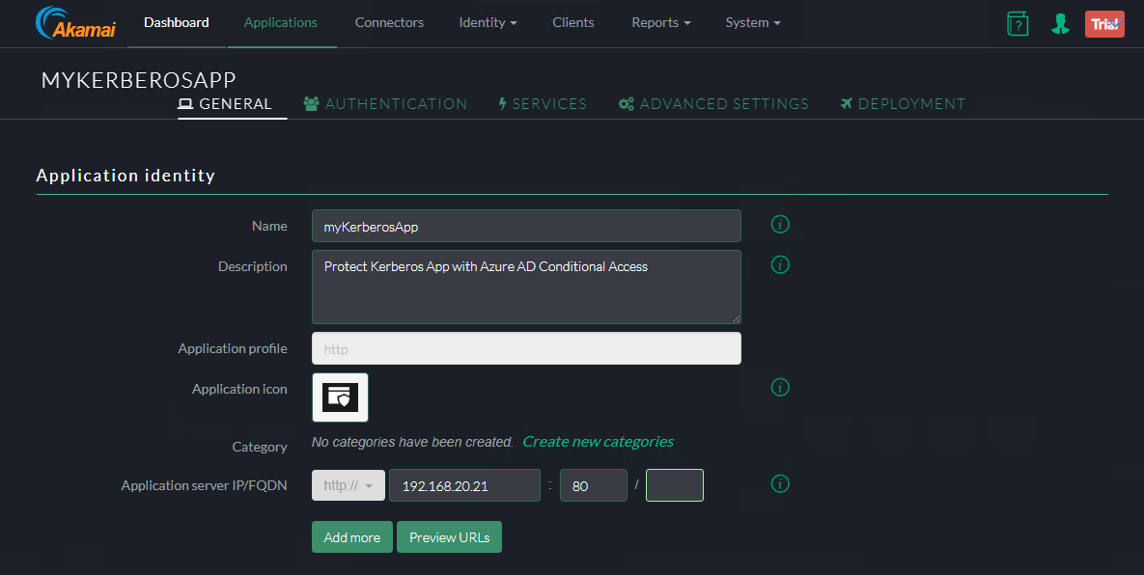

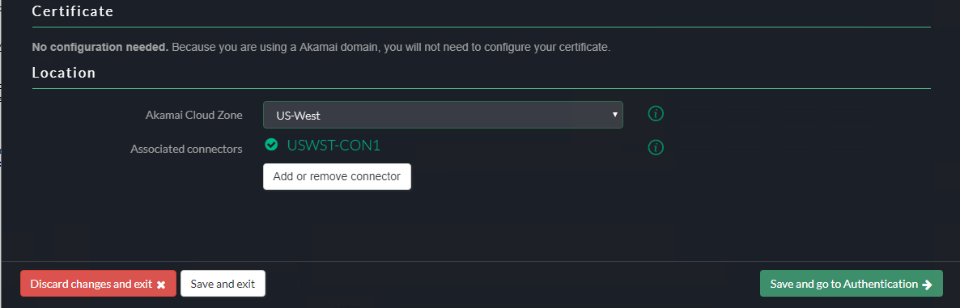

**Authentication Tab**

Assign the Identity Provider

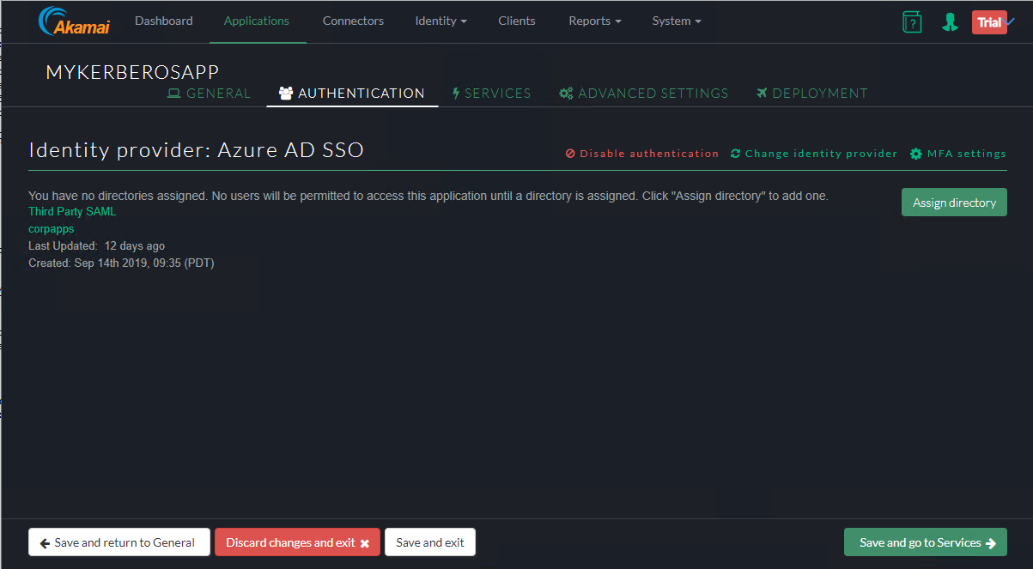

**Services Tab**

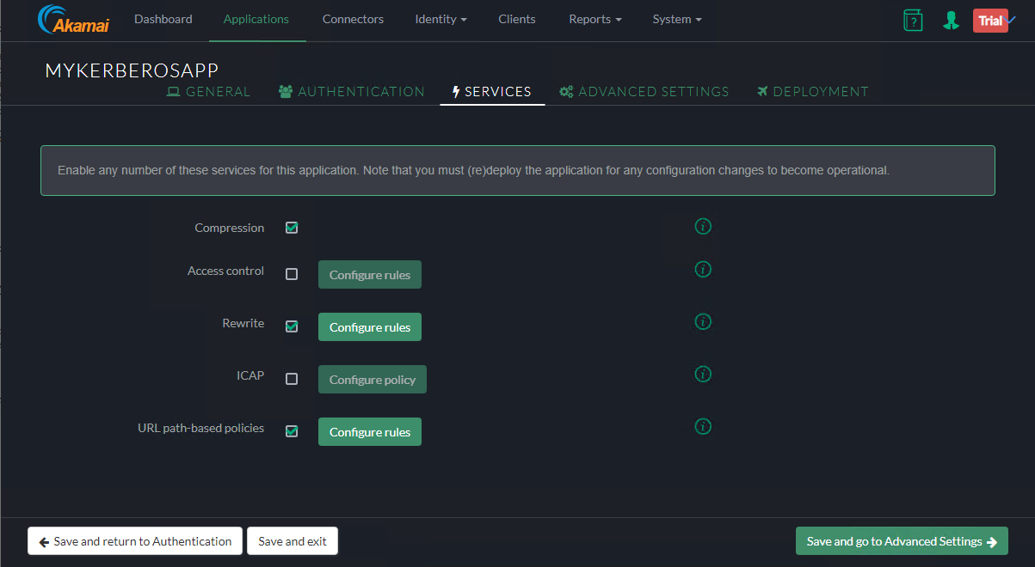

Advanced Settings

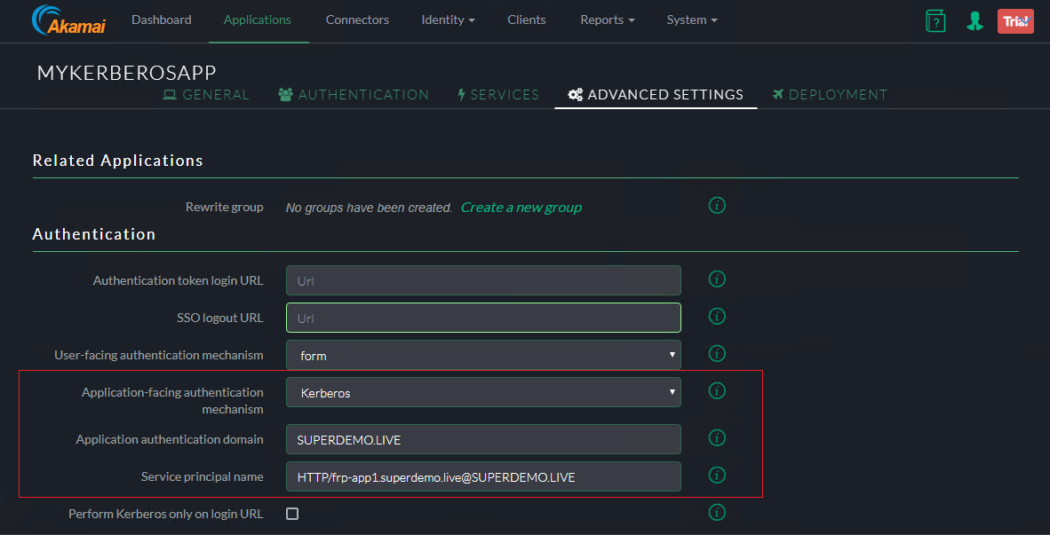

Note : The SPN for the Web Server has be in SPN@Domain Format

ex. [**HTTP/frp-app1.superdemo.live@SUPERDEMO.LIVE**](mailto:HTTP/frp-app1.superdemo.live@SUPERDEMO.LIVE) **for this demo**

Leave rest of the settings to default.

**Deployment Tab**

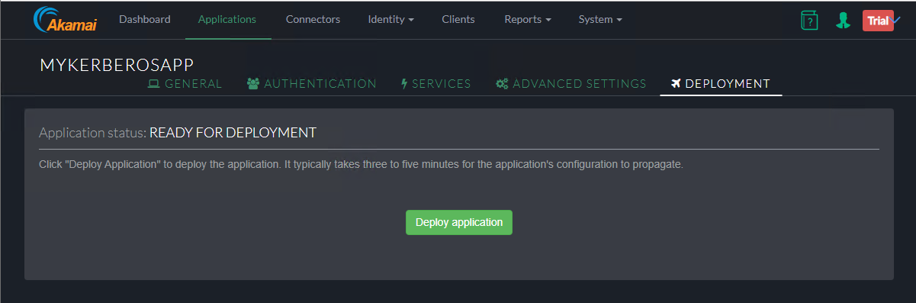

Adding Directory

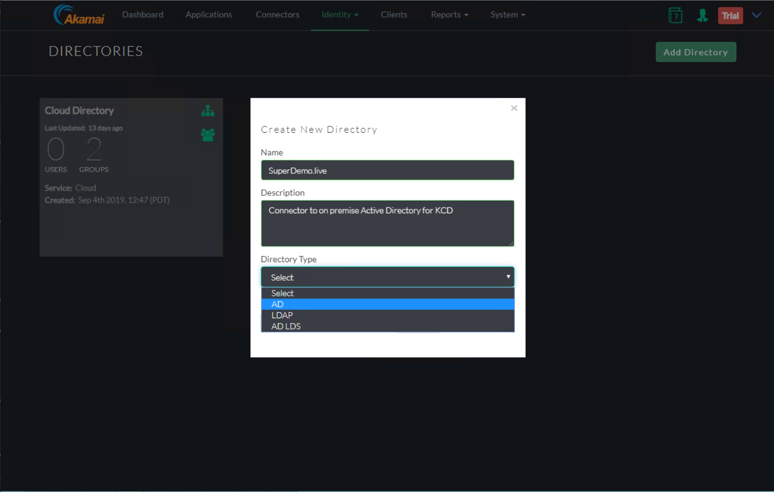

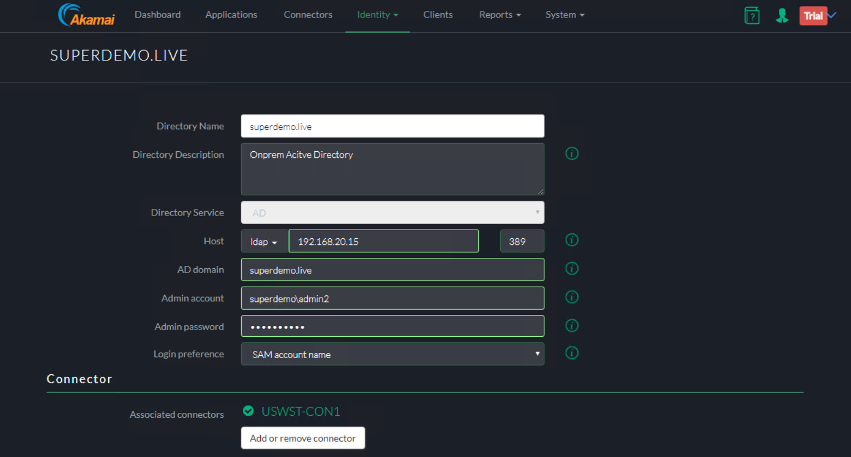

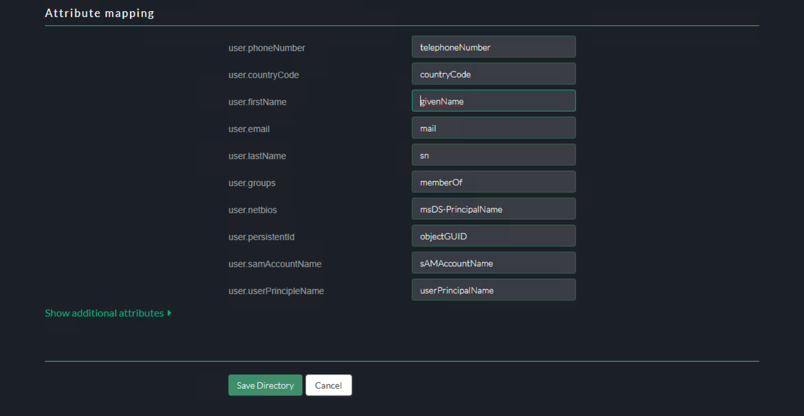

Verify the Directory Creation

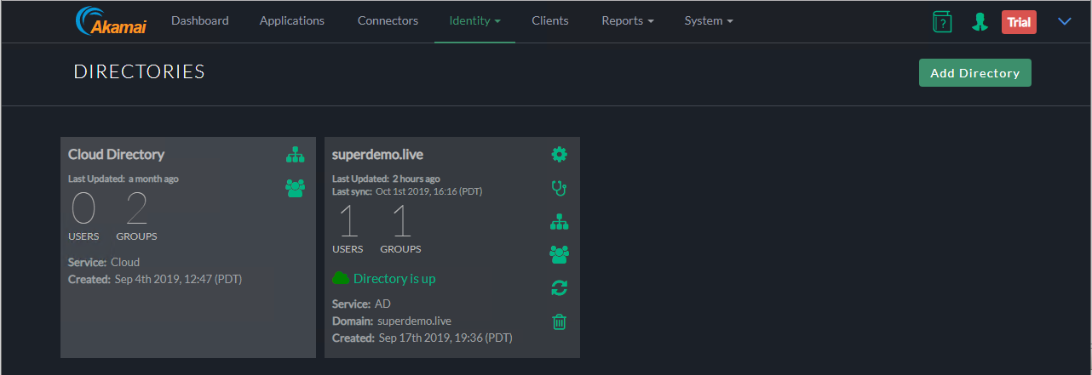

Add the Groups/OUs who would be require access



In the below the Group is called EAAGroup and has 1 Member

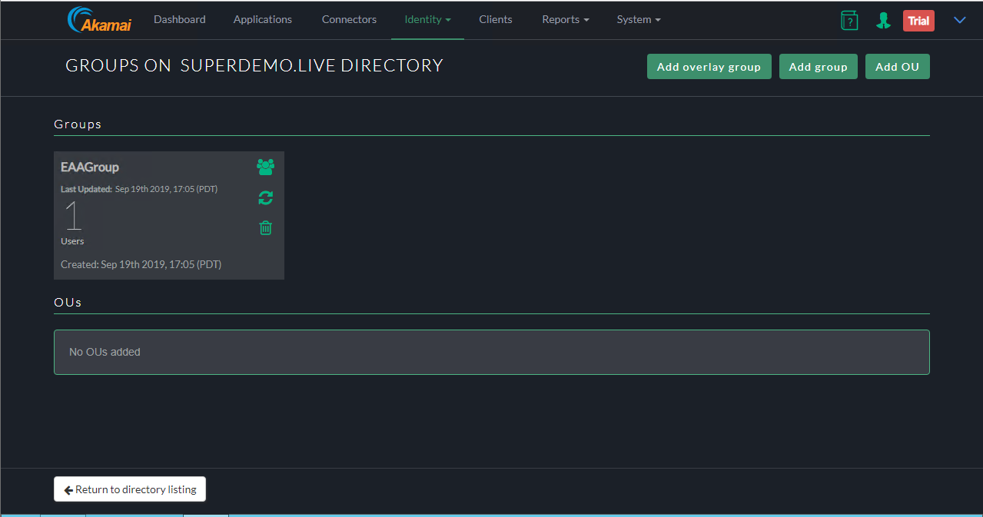

Add the Directory to you Identity Provider by clicking : Identity > Identity Providers

* Click on the Directories Tab and Click on Assign directory

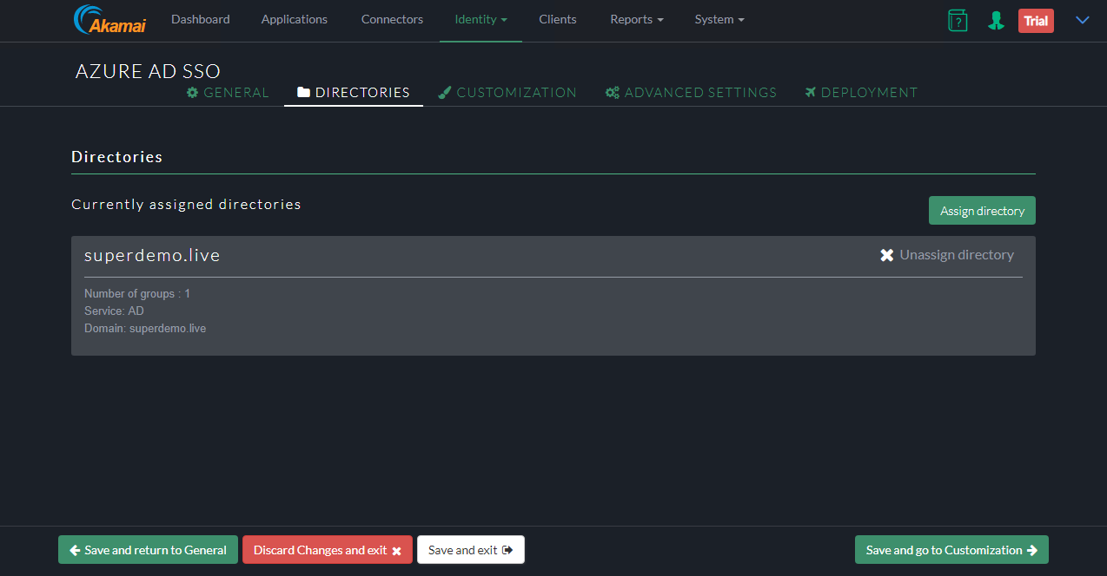

**Configure KCD Delegation for EAA Walkthrough**

**Step 1: Create an Account**

In the example we will use an account called **EAADelegation**

You can perform this using the **Active Directory users and computer** Snappin



**Figure 1 : Identity Provider Tile in the Akamai EAA Console**

Note: The user name has to be in a specific format based on the **Identity Intercept Name.** From the figure 1 we see it is **corpapps.login.go.akamai-access.com**

User logon Name will be : **HTTP/corpapps.login.go.akamai-access.com**

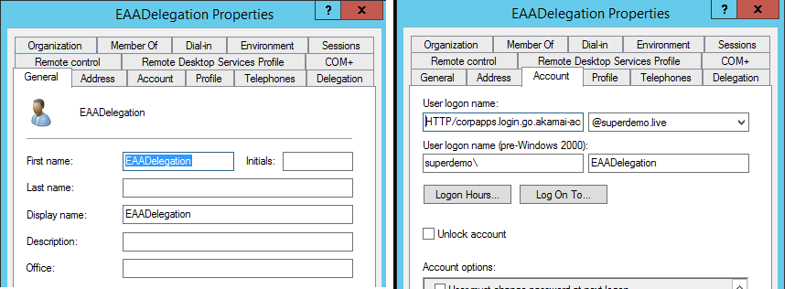

**Step 2: Configure the SPN for this account**

Based on this sample the SPN will be as below

setspn -s **Http/corpapps.login.go.akamai-access.com** **eaadelegation**

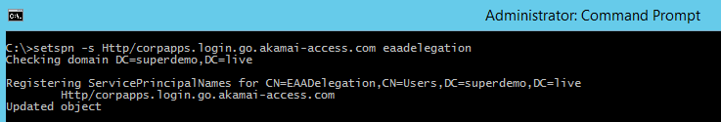

**Step 3: Configure Delegation**

For the EAADelegation account click on the **Delegation** tab

* Specify **use any authentication Protocol**
* Click Add and Add the App Pool Account for the Kerberos Website. It should automatically resolve to correct SPN if configured correctly.

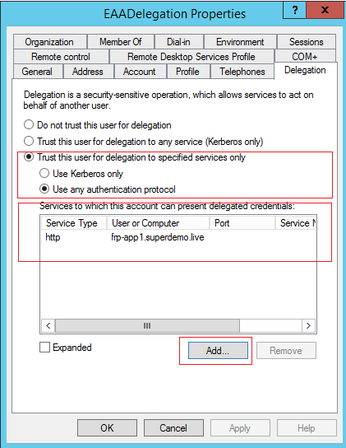

**Step 4 : Create a Keytab File for AKAMAI EAA**

Here is the generic Syntax

ktpass /out ActiveDirectorydomain.keytab /princ [HTTP/yourloginportalurl@ADDomain.com](mailto:HTTP/yourloginportalurl@ADDomain.com) /mapuser serviceaccount@ADdomain.com /pass +rdnPass /crypto All /ptype KRB5_NT_PRINCIPAL

Example explained

|  |  |
| --- | --- |
| Snippet | Explanation |
| Ktpass /out EAADemo.keytab | // Name of the output Keytab file |
| /princ HTTP/corpapps.login.go.akamai-access.com@superdemo.live | // HTTP/yourIDPName**@**YourdomainName |
| /mapuser [eaadelegation@superdemo.live](mailto:eaadelegation@superdemo.live) | // EAA Delegation account |
| /pass RandomPass | // EAA Delegation account Password |
| /crypto All /ptype KRB5_NT_PRINCIPAL | // consult Akamai EAA documentation |
|  |  |

Ktpass /out EAADemo.keytab /princ HTTP/corpapps.login.go.akamai-access.com@superdemo.live /mapuser eaadelegation@superdemo.live /pass RANDOMPASS /crypto All ptype KRB5_NT_PRINCIPAL

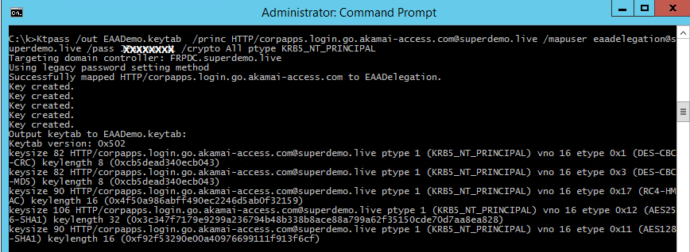

**Step 5 : Import Keytab in the AKAMAI EAA Console**

**Click System > Keytabs**

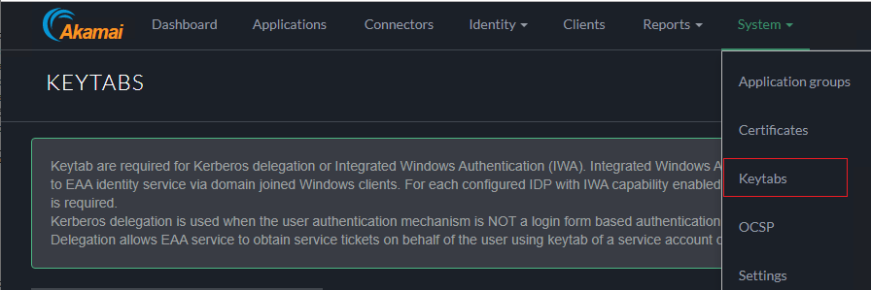

In the Keytab Type choose **Kerberos Delegation**

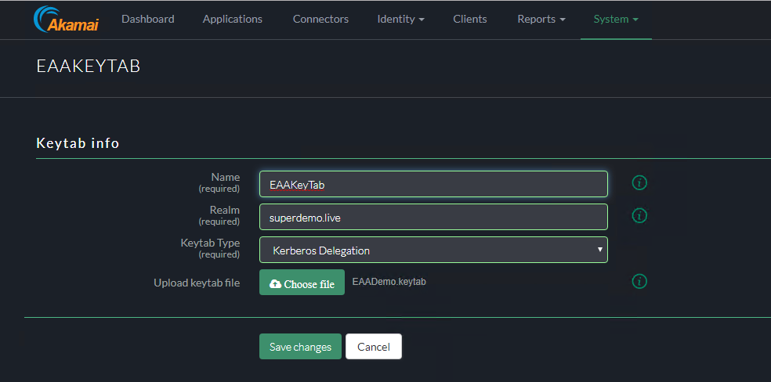

Ensure the Keytab shows up as Deployed and Verified.

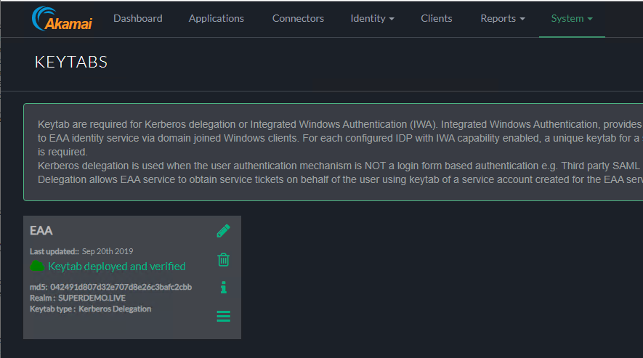

User Experience

End-User Experience





Conditional Access



